

**Advanced Digital Systems Design**

**ENCS3310**

**Course Project**

**Prepared By: Rama Abdlrahman**

**ID: 1191344**

**Instructor: Dr. Abdellatif Abuissa**

**Section: ‘1’**

**Date: 18 12 2021**

Abstract:

The aim of this project is to get familiar with the VHDL language by designing an 8 bit comparator for signed numbers, using the software Active-HDL, and we have to do that in two stages. It also aims to learn and simulate functional verification for the design.

Table of contents:

Contents

Introduction 5

Theory: 6

1) Gate: 6

2 ) FULL ADDER/SUBTRACTOR: 7

Ripple Carry Adder 7

Carry Lookahead Adder 8

1-Bit Magnitude Comparator 10

Functional Verification 11

❖Design Philosophy: 12

• Gates: 12

Mechanism : 13

Time delay 18

4) Results and Discussion 20

Conclusion and Future works 31

References 31

Tables

Table 1 gates 12

Table of Figures

Figure I gates 7

Figure II FULL ADDER/SUB 7

Figure III 8 bit ripple adder 8

Figure IV 4 bit ripple adder/SUB 8

Figure V carry look ahead generater 9

Figure VI 8 bit carry look a head adder 10

Figure VIII magnitude comparator 11

Figure VII 8 bit signed comparator from adder 11

Figure IX 8 bit magnitude comparator for signed numbers 12

Figure X functional verification 13

Figure XI example of comparing after adding 15

Figure XII following the same example 16

Figure XIII combinational design connected with flip flops. 17

Figure XIV time delay1 19

Figure XV time delay2 20

Figure XVI time delay 3 20

Figure XVII time delay4 21

Figure XVIII time delay5 21

Figure XIX simulation stage 1 e 23

Figure XX simulation stage 1d 23

Figure XXI simulation stage 1 c 23

Figure XXII simulation stage 1b 23

Figure XXIII simulation stage 1 a 23

Figure XXIV simulation stage 2d 25

Figure XXV simulation stage 2c 25

Figure XXVI simulation stage 2b 25

Figure XXVII simulation stage 2a 25

Figure XXVIII CLOCK 26

Figure XXIX RUNNING NO ERRORS 26

Figure XXX ALSO RUNNING NO ERRORS 27

Figure XXXI ANOTHER PIC FOR RUNNING WITH NO ERRORS 27

Figure XXXII ERRORS DITECTED 28

Figure XXXIII ERRORS DETECTED B 28

Figure XXXIV ERRORS DETECTED C 29

Figure XXXV ERRORS DETECTED D 29

Figure XXXVI WITHOUT ERRORS 30

Figure XXXVII RUNNING WITHOUT ERRORS s2 30

Figure XXXVIII RUNNING WITH ERRORS S2 31

Figure XXXIX RUNNING WITH ERRORS S2 A 32

Figure XL SIMULATION FOR VIRIFECTION STAGE 1 33

Figure XLI SIMULATION FOR VIRIFECATION STAGE 2 34

# Introduction

In this project, a 8bit comparator will be implemented structurally using two types of 8-bit adders, the Carry Ripple Adder and the Carry Look-ahead Adder, also will be implemented as a magnitude comparator( in stage 2). The design will be done by the VHDL language using the software Active-HDL. In order to make the comparator synchronous with no glitches, the comparator will be fed to/through flip-flops with proper clock speed which is obtained by determining the maximum delay in each type of implementations. Also, functional verification for the two designs will be designed and simulated to verify that the design worked properly

## Theory:

# 1) Gate:

A)Inverter : Inverter gate is also known as Not. It has one input A and one output Y.

B) AND gate : A circuit which performs an AND operation. It has n input (n >= 2) and one output.

C) OR gate : A circuit which performs an OR operation . It has n input (n>= 2) and one output.

D) NAND gate : A NOT-AND operation is known as NAND operation. It has n input (n >= 2) and one output.

E) XOR gate : It can be used in the half adder, full adder and subtractor. It has n input (n >= 2) and one output.

F( NOR : **a digital logic gate** whose function is the logical complement of OR gate.

G) XNOR: **a digital logic gate** whose function is the logical complement of the Exclusive OR (XOR) gate.

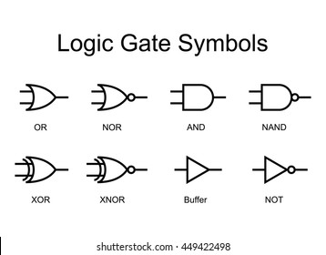

Figure gates

# 2 - FULL ADDER/SUBTRACTOR:

1-Bit full adder/sub is a component that adds/ subtract two 1-bit numbers with the carry input from a previous operation. It could be built from basic gates such as XOR, AND and OR gates.Various adder structures can be used to execute addition/subtraction such as ripple carry adder and carry look ahead adder, each with good attributes and some drawbacks.

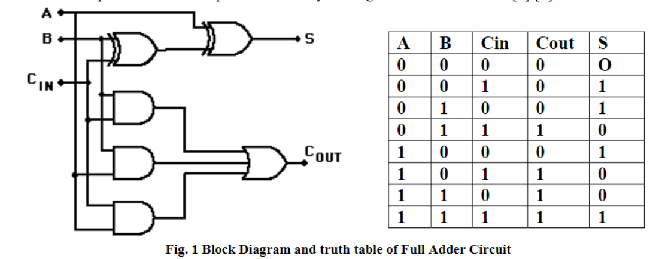

Figure FULL ADDER/SUB

# Ripple Carry Adder

(RCA) is simple several full adders connected in series so that the carry must propagate through every full adder before the addition is complete. Each full adder inputs a Cin, which is the Cout of previous adder. This kind of adder is a ripple carry adder, since each carry bit ripples to the next full adder. RCA require the least amount of hardware of all adders, but they are the slowest.

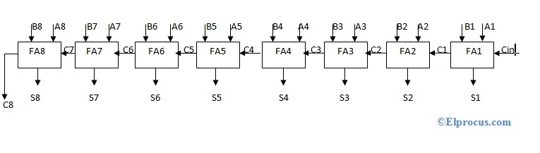

Figure 8 bit ripple adder

To let this ripple adder work as subtractor we just let B enter xor gate with

the cin, cin should be 1 in subtraction ,like this :

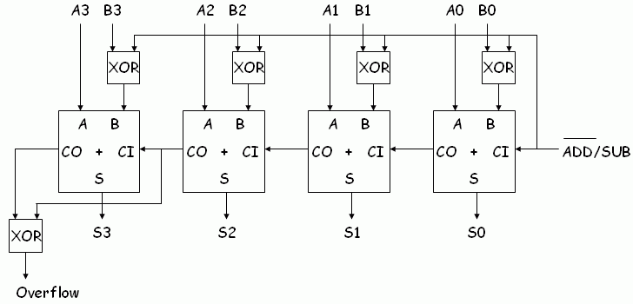

Figure 4 bit ripple adder/SUB

# Carry Lookahead Adder

(CLA) A fast method of adding numbers. This method does not require the carry signal to propagate stage by stage, causing a bottleneck. Instead it uses additional logic to expedite the propagation and generation of carry information, allowing fast addition at the expense of more hardware requirements. This type of adders requires less time than the normal 8-bit carry ripple adder. Since, the amount of time required to determine the carry bits is reduced. It is based on a carry look-ahead generator that is built according to the following equations.

𝑃𝑖 = 𝐴𝑖 ⊕ 𝐵𝑖

𝐺𝑖 = 𝐴𝑖𝐵𝑖

𝑆𝑖 = 𝑃𝑖 ⊕ 𝐶𝑖

𝐶𝑖+1 = 𝐺𝑖 + 𝑃𝑖𝐶𝑖

Where 𝐺𝑖 is the carry generate which produces a carry of ‘1’ when both inputs are ‘1’ regardless the value of the input carry 𝐶 . And 𝐺𝑖 is the carry propagate because it determines whether a carry will propagate to the next stage. Using these equations, the circuit diagram of the generator is built .

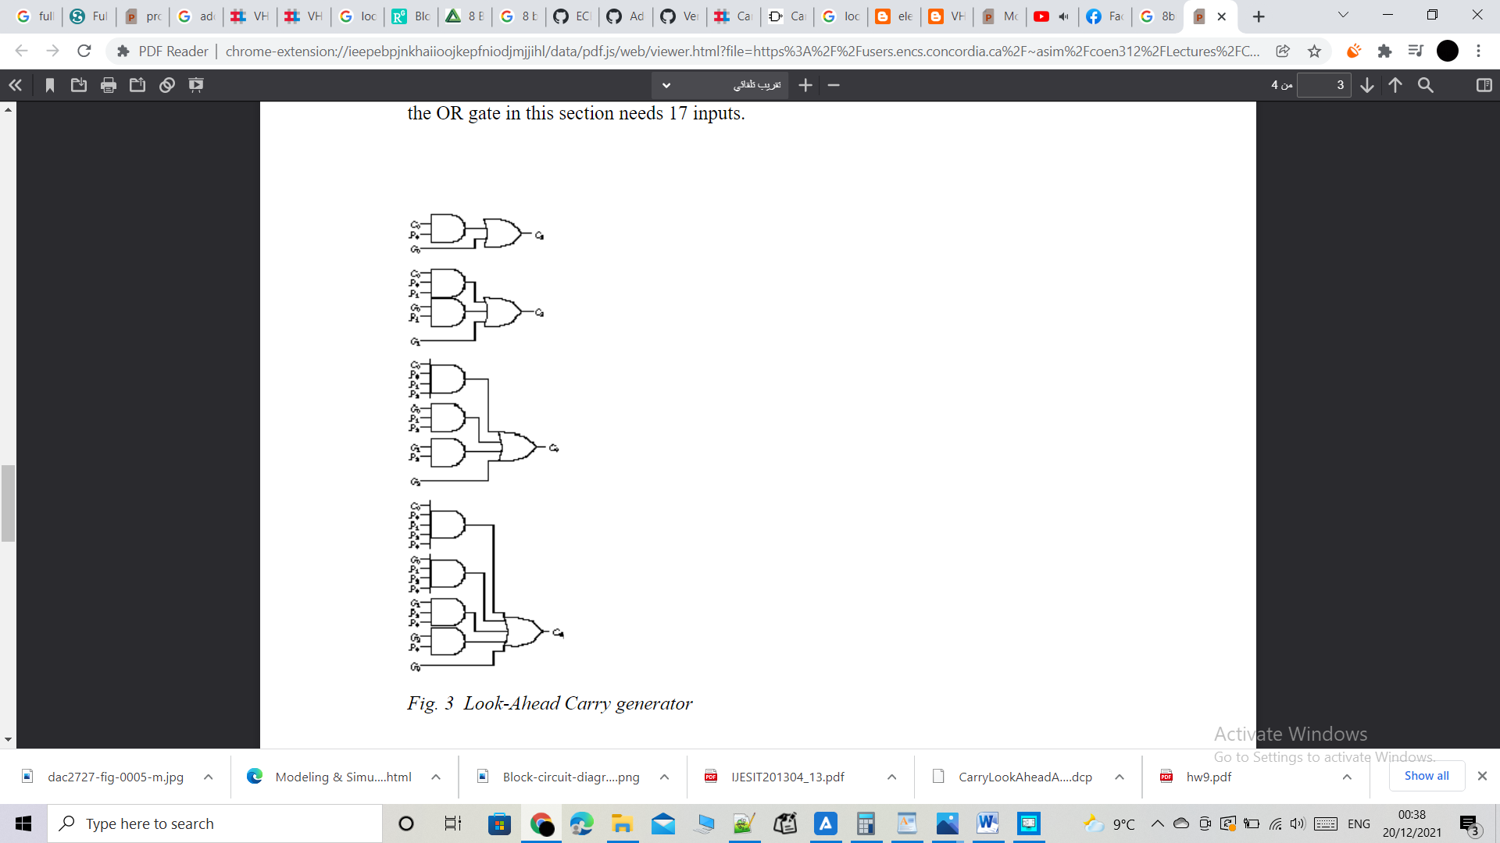

Figure carry look ahead generater

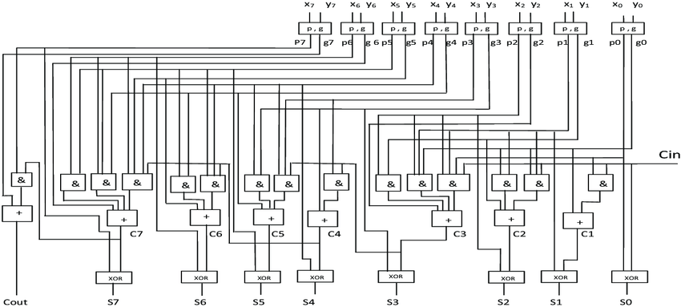

Figure 8 bit carry look a head adder

# 1-Bit Magnitude Comparator

**A comparator used to compare two bits** is called a single bit comparator. It consists of two inputs each for two single bit numbers and three outputs to generate less than, equal to and greater than between two binary numbers.it could be built using different gates 2 invertors, 2 and gates, and one nor gate or one xor gate or one xnor gate , and maybe other implementations.

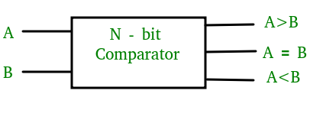

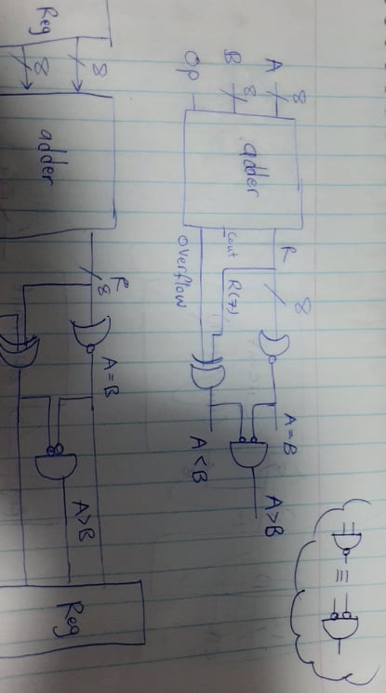Figure magnitude comparator

Figure 8 bit signed comparator from adder

8 bit signed comparator could be built structurally from 8-bit adder regardless how this adder built(ripple or carry look ahead). (stage 1).

Also, 8 bit signed comparator could be built structurally from 1 bit magnitude comparator with other gates that will deal with the sign . (stage 2).

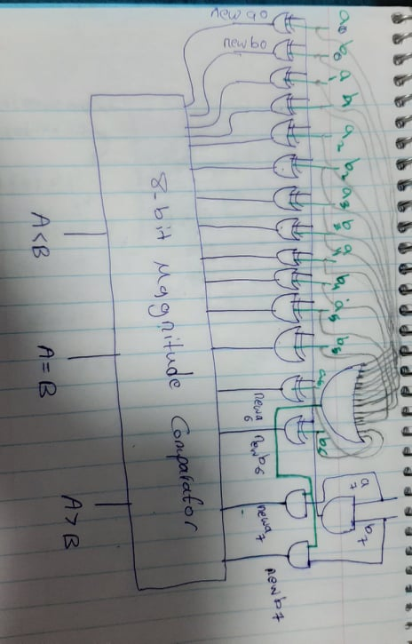

Figure 8 bit magnitude comparator for signed numbers

## Functional Verification

Functional verification is a procedure to test whether a system is working properly or not. If not, it can detect that there is something wrong. It is based on three components, the Test Generator, the System under system, the Result Analyzer.The Test Generator generates the whole test vectors possible and feeds them to the inputs of the system under test, and generates the expected result from the system under test and feed it to the Result Analyzer. It must be built behaviorally in order to guarantee that the expected result generated is the correct answer. Since the result from the system under test will be compared with this result. The system under test is the system that requires verification. And the Result Analyzer receives the expected result from the test generator and the result of the same test vector from the system under test. It determines whether the two results are the same or not. If not, it will report a message according to the severity type.

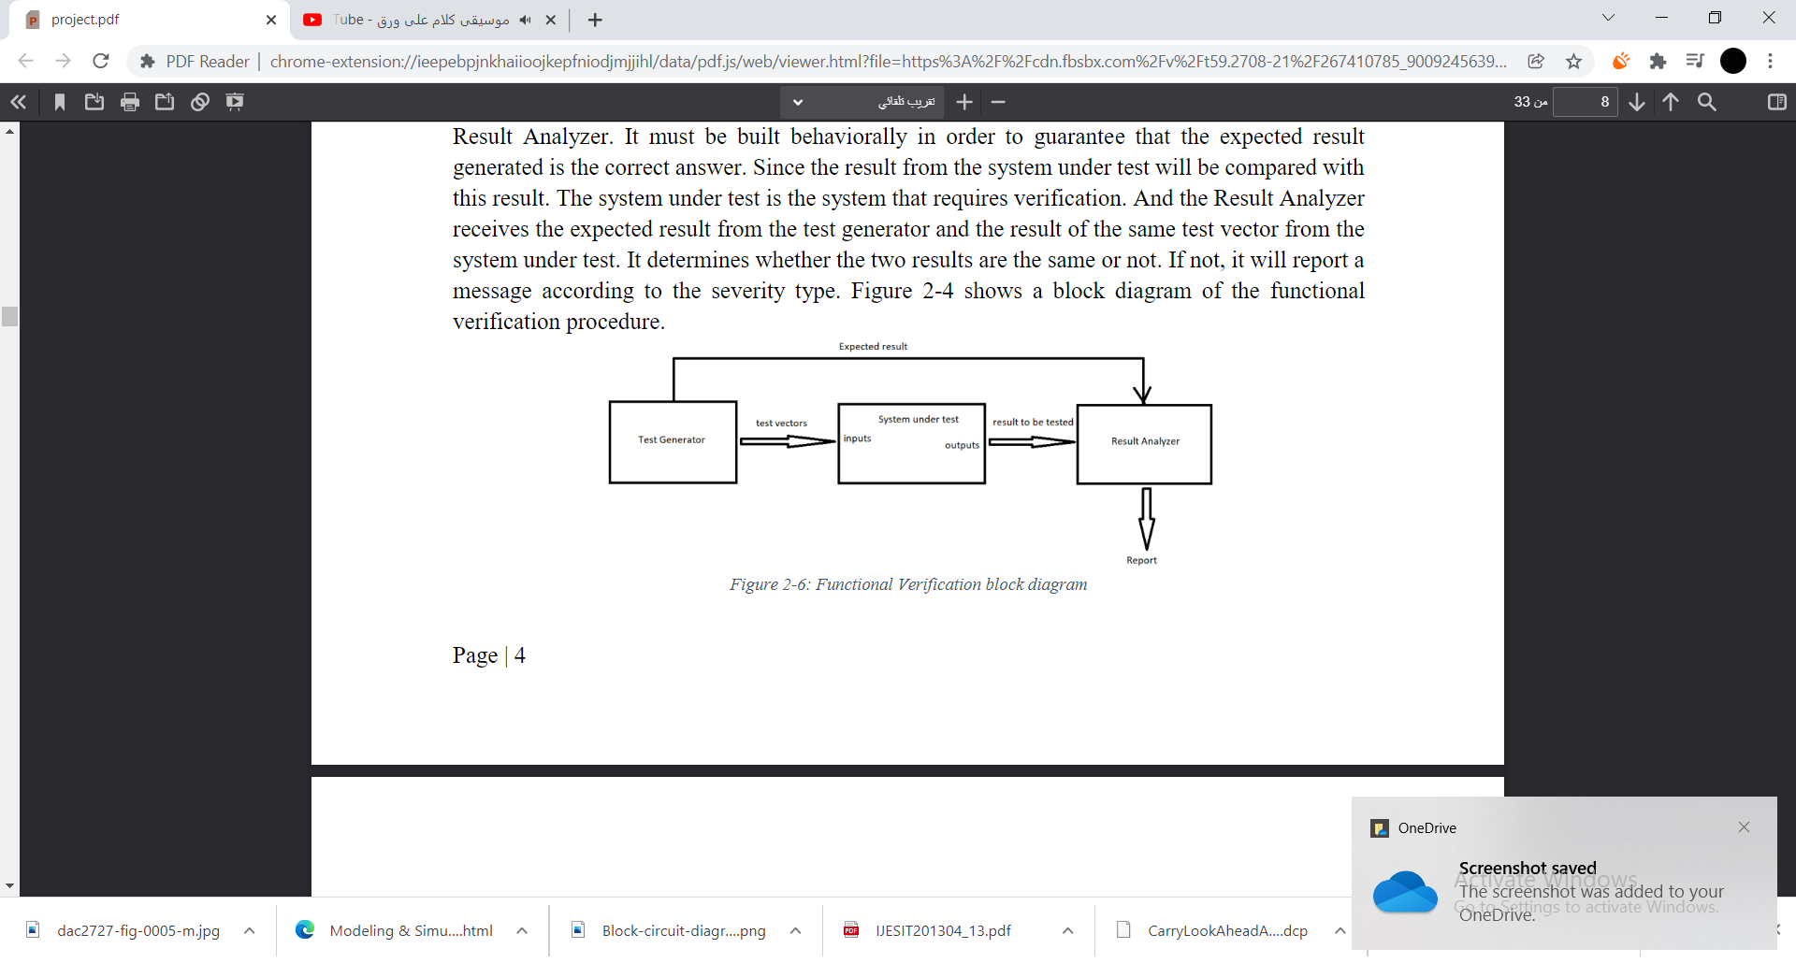

Figure functional verification

# 

# Design Philosophy:

## • Gates:

In this project I have used these gates in my design :

I have used more than 2 ports gate of some of these gates

Table gates

|  |
| --- |
| Gate Delay |
| Inverter 2 ns |
| NAND 5 ns |
| NOR 5 ns |
| AND 7 ns |
| OR 7 ns |
| XNOR 9 ns |
| XOR 12 ns |

## Mechanism :

First ,I have built the basic gates such as AND, OR and XOR with different number of inputs as I need in the design. Each gate has a specific delay . and each gate has it its own entity and architecture as shown in appendix .

Then, 1-bit full adder was built structurally from the basic gates: xor gate with 2 inputs, 3 and gates each with 2 inputs, or gate with 2 inputs . The code could be found in appendix. Simulation for this FA done to check it is works properly.

Input and output D flip-flop were designed to make the system synchronous that operates on the positive edge of the clock.

And Regester designed structurly from flip flop. The codes of the input and output flip-flop and regester could be found in appendix respectively.

The 8-bit adder/subtractor was built structurally from four the 1-bit full adders according to the schematic shown in figure 9 in theory. To let this ripple adder work as subtractor we just let B enter xor gate with the carry in

The 8-bit signed comparator was built structurally from 8-bit carry ripple adder according to the implementation shown in figure 14(in theory). And from other needed gates.

How it work?

We get the equality A=B by making the result of adder pass through nor gate( nor gate with 8 inputs) – or using invertors and (and gates) - .

We get the A<B by making the last bit of result R(7) pass through xor gate with the overflow ,So we used( xor gate with 2 inputs ), the overflow is the result of passing the last two carries in xor gate.

We get A>B by passing A<B into invertor, and A=B also into another invertor , and the result of each passed through and gate ( which means if A not equal B and not less than it, then it is greater).

The code for this design could be found in appendix .

Example in the figure bellow:

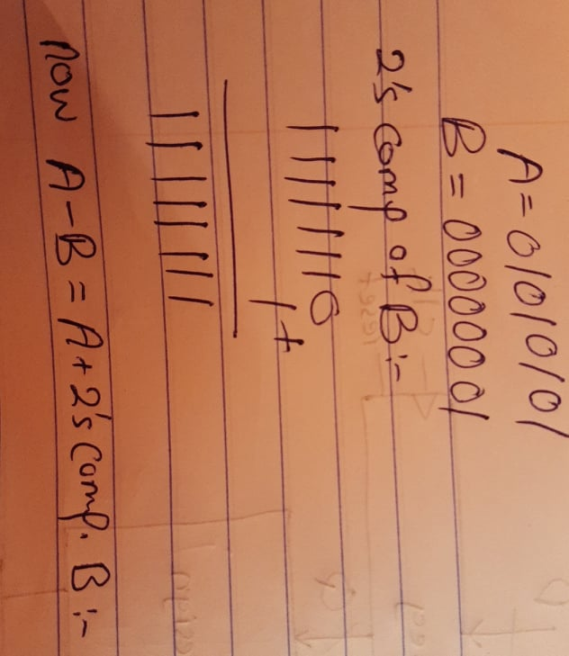

Figure example of comparing after adding

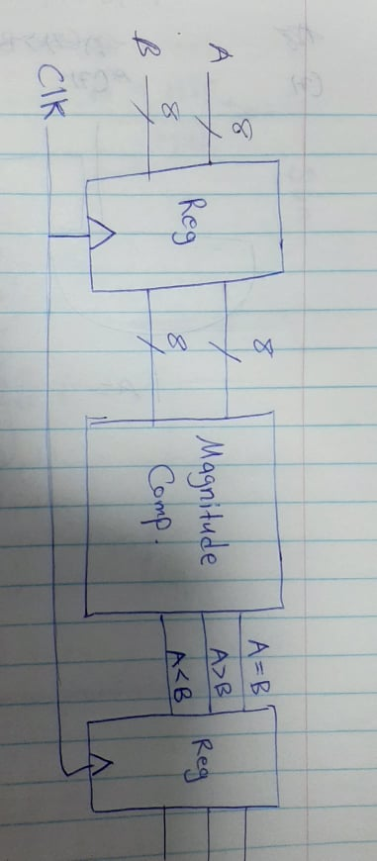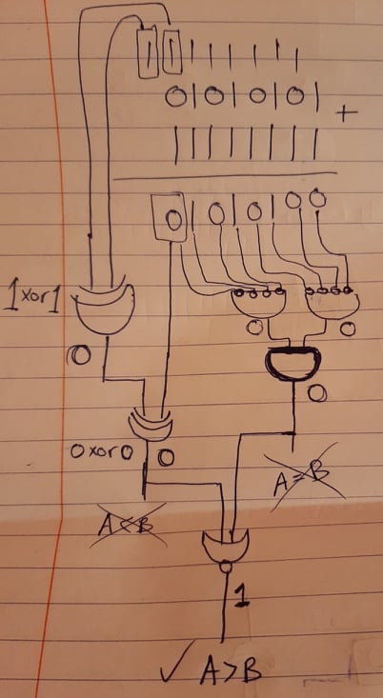

Figure following the same example

Finally, the design was connected with the flip-flops I built before to generate final system .

Figure combinational design connected with flip flops.

After that, the carry look-ahead generator, which will be used to build the 8-bit carry look-ahead adder, was designed according to the circuit diagram shown in figure 11. The code of the design could be found in appendix.

Then, the 8-bit carry look-ahead adder was built structurally using the carry look-ahead generator according to the implementation shown in figure 12.

The 8-bit signed comparator was built structurally from the 8-bit carry-look ahead adder, and the design was connected with the flip-flops I built before to generate final system. The code could be found in appendix .

**For stage 2:**

1 bit magnitude comparator was built structurally from the basic gates: 2 invertors,2 and gates, one nor gate. The code could be found in appendix .

Then I had to build 8 bit magnitude comparator for signed numbers , so I built it structurally from 1 bit magnitude comparator and from other basic gates deals with the sign(look at figure 15 in theory):

My comparator works as following :

If It is comparing 2 signed numbers, it will compare the bits from 0 to 6 after inverting them using xor gates,also I needed and gat for sign bit of two numbers ( the method explained in a figure15 in theory), with out the digit 7 (sign bit ), it will be fixed , so if a(6 to 0) greater than b(6 to 0), then a (7 to 0 )will be greater than b(7 to 0 ) .

If It is comparing unsigned number with signed number ,the numbers will be fixed, the gates I used will not affect, but what happens is that the number with greater last bit (7) ,will be less than the other number . I mean if a=1010, b=0101, and a(7) as we can notice greater than b(7), then a less than b(a is the signed number). That is done by replacing the places of the outputs of the 1 bit comparator for the last bit. So instead of making the output (a7 greater than b7) go through the or gate that give the output a greater than b, I make it go through the other or gate that gives the answer a less than b, and the same for (a7 less than b7), instead of making it go through the or gate that give the output a less than b, I make it go through the other or gate that gives the answer a greater than b.

If It is comparing 2 unsigned numbers,the numbers will be fixed, the gates I used will not affect, all digits will be compared normally .

I was facing problem when comparing a=10000000(-0) andb= 00000000(0) , it was giving me that +0>-0 , And that is not correct , and that’s why I used or gate the inputs of it would be a(6 to 0), b(6 to 0) and the output of it (0) will be input of and gate with a7 which is(1) so it will give zero, also the output of it will be input of and gate with b7 which is(0) so it will give zero, so we get a=b (+0=-0).

Finally, the design was connected with the flip-flops I built before , then we generate final system .

----------------------------------------------------------------------------------------------

For the functional verification, the Test Generator was designed for each design(stage1&2), to generate the required test vectors and the expected results with the positive edge of a clock.

The, the Result Analyzer was designed for each design(stage1&2) ,to report “Incorrect Design” when something wrong is detected.

The test-bench for the design verification (self test) was designed for each design(stage1&2) ,and using the proper clock speed for each design.

The code of the Test Generator and the Result Analyzer self test could be found in appendix.

***************************************************************

## Time delay

The maximum frequency is the worst-case delay for every gate wired in series. We need to look for is the longest path (in number of gates) for any possible input signal to any possible output signal. This is the critical path when it comes to timing.

For my two designs(stage1&2):

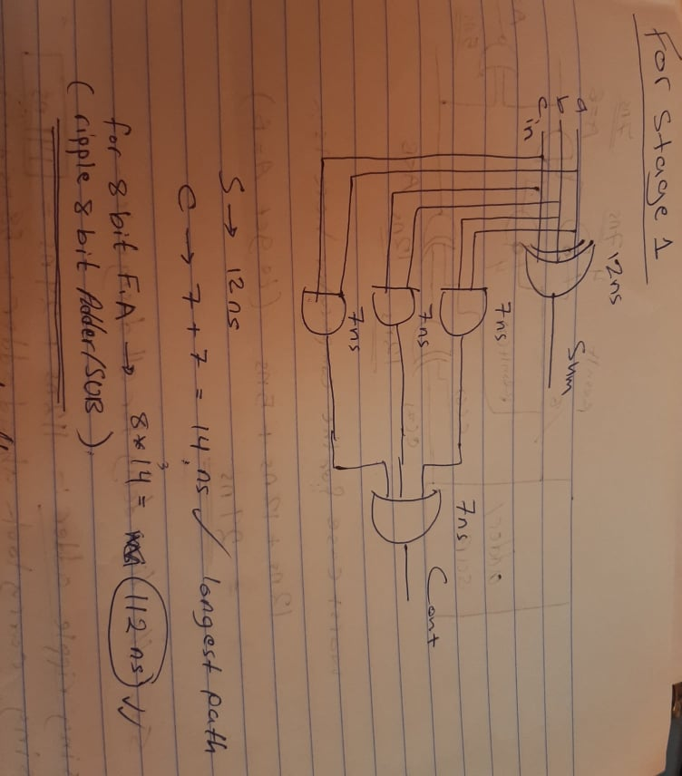

Figure time delay1

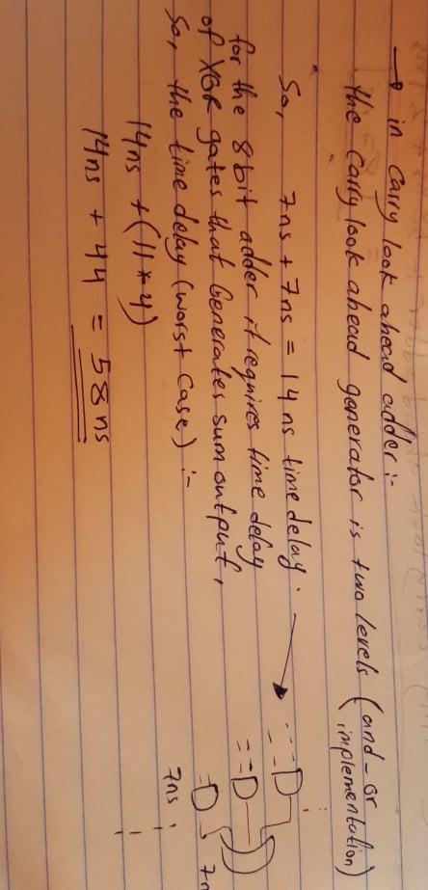

Figure time delay2

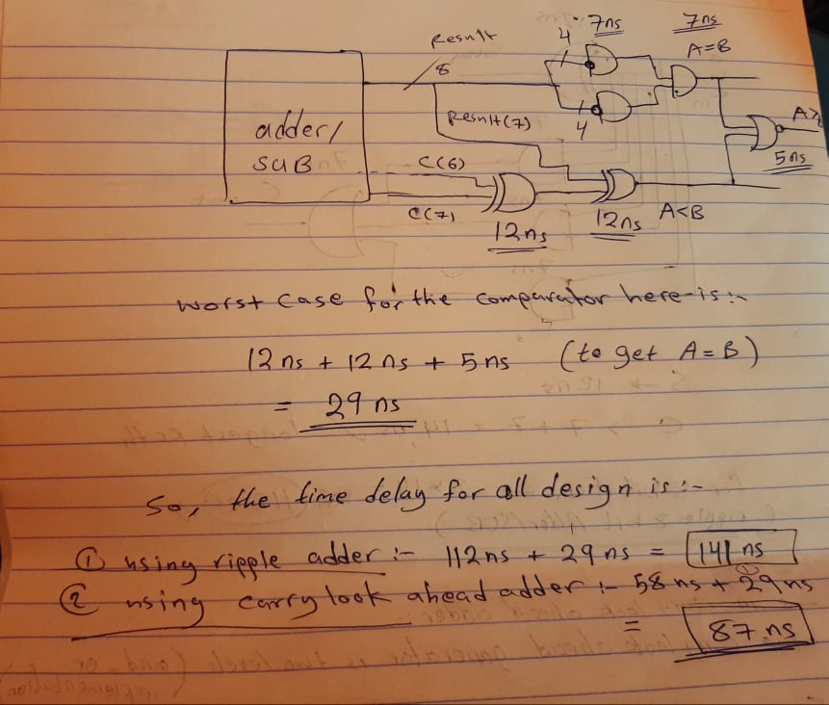

Figure time delay 3

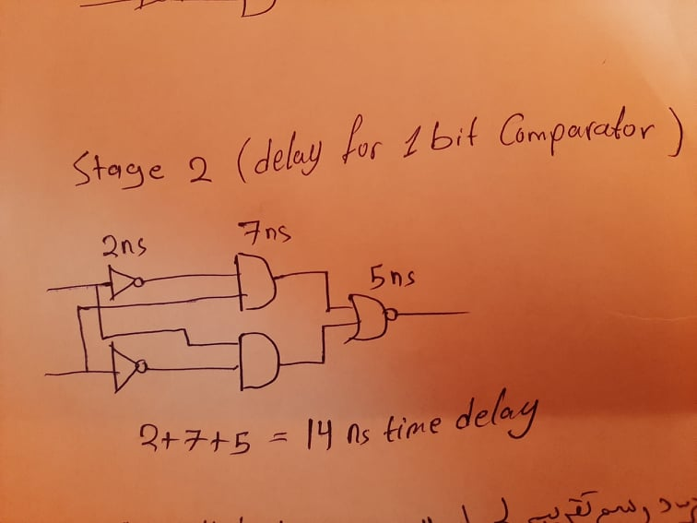

Figure time delay4

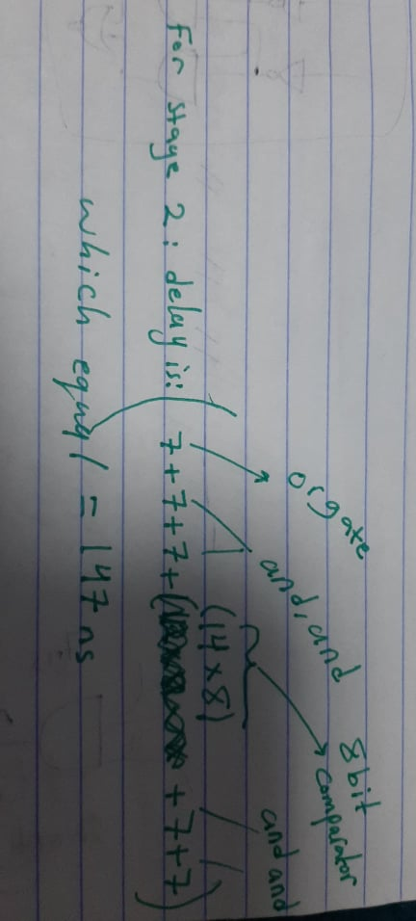

Figure time delay5

**************************************************************************

# 4) Results and Discussion

Building the components structurally

some gates were used with different number of inputs. Each gate was built with its own entity and architecture. However, it is possible to define four entities called gat2 (takes 2 inputs), gate3, gate4 and gate5, and so on. and the three operations could be defined in different architectures for the same entity, and the architecture could be named according to its operation. For example, three architectures for the entity gate2 could be defined as and2, or2, xor2, nor2 and for example inside the architecture and2 define and operation. This is better design and reduces code length and number of entities. But, I didn’t follow this method.

The 1-bit full adder was simulated on a waveform. The results were as expected. so it was designed correctly. And The 8-bit carry ripple adder and the 4-bit carry look-ahead adder designs were checked that they were working properly using test benches . The results were as expected.

And The 8-bit comparator from carry ripple adder and the 8-bit magnitude comparator designs were checked that they were working properly using simulation and using verification code. And The results were as expected.

**Simulation results for both stage 1 and stage 2: (checking some values)**

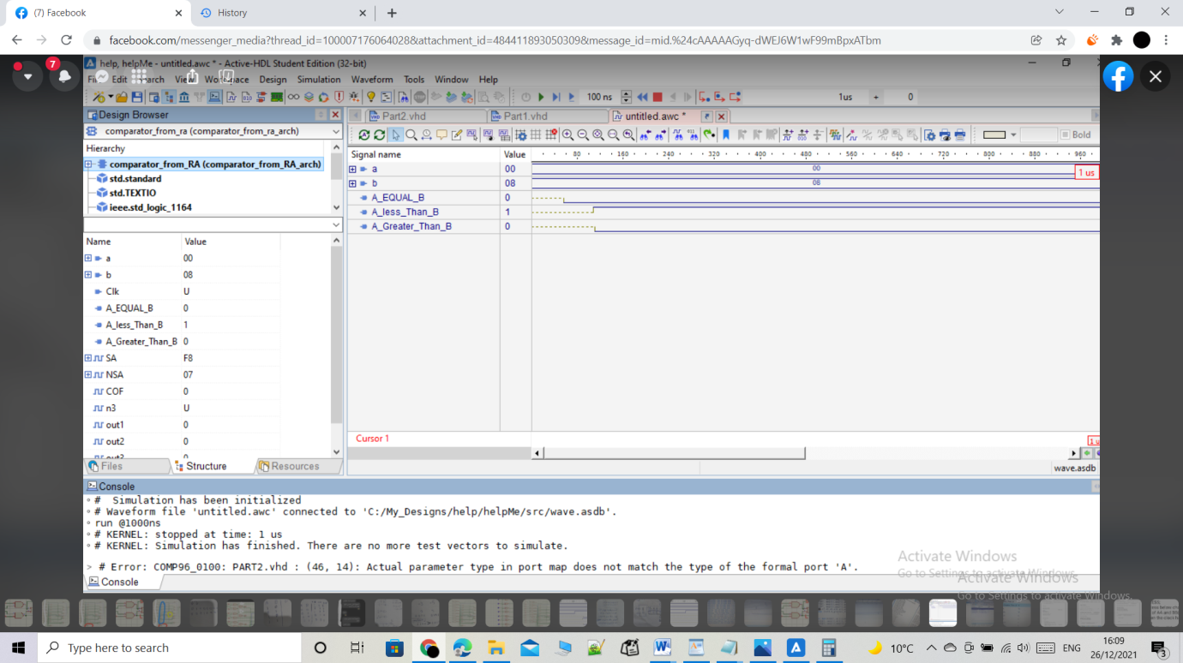**For stage 1:**

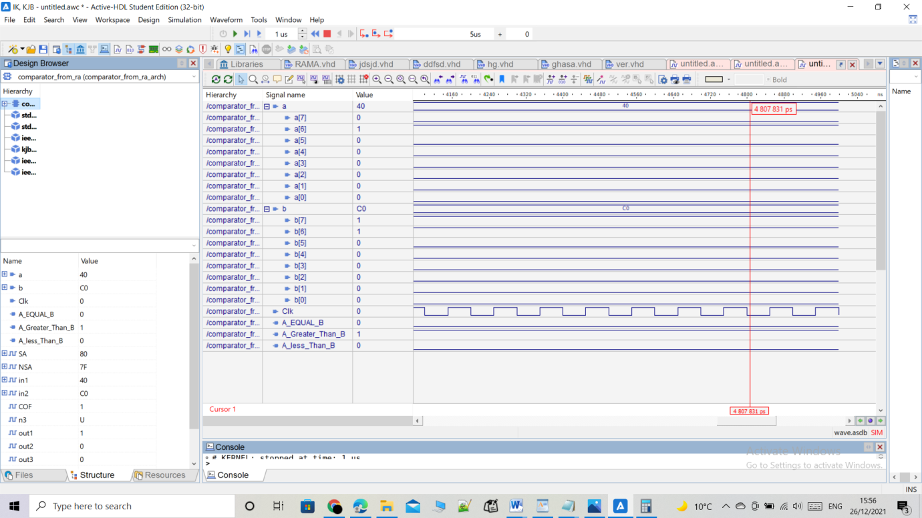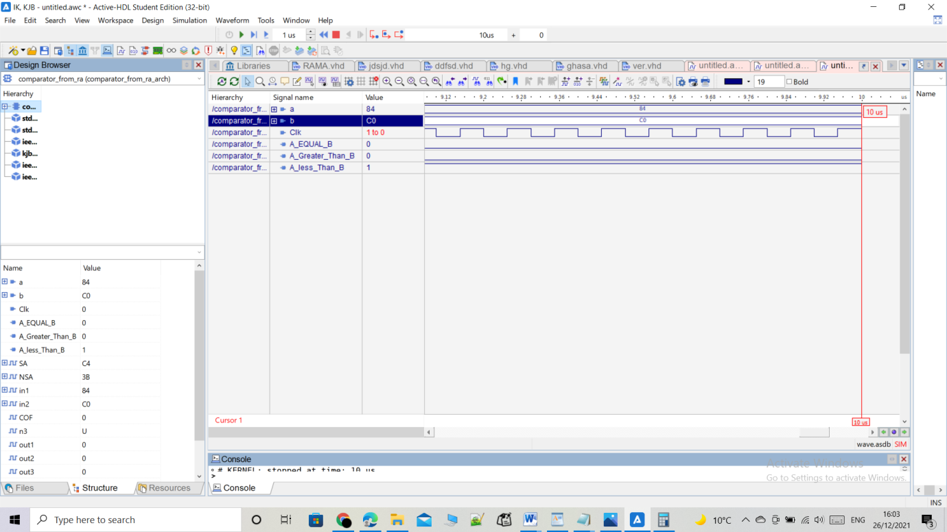

Figure simulation stage 1b

Figure simulation stage 1 a

Figure simulation stage 1 e

Figure simulation stage 1d

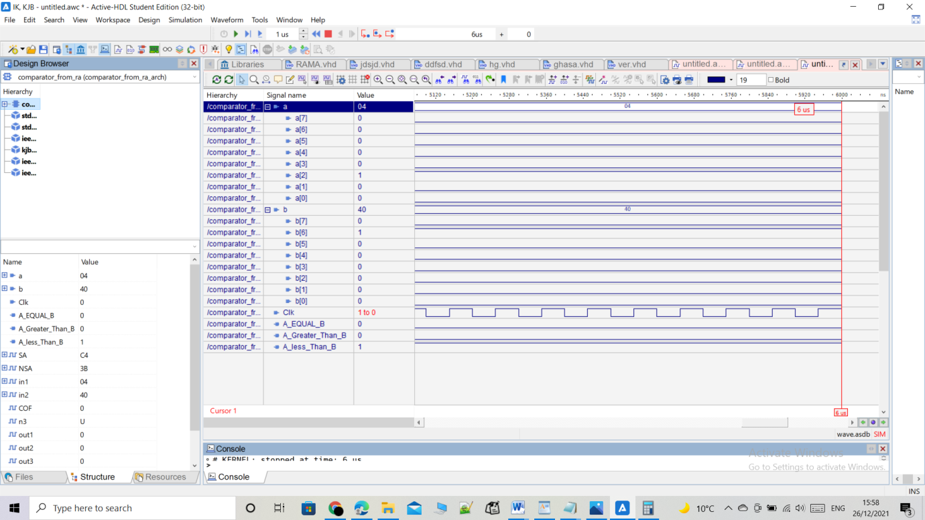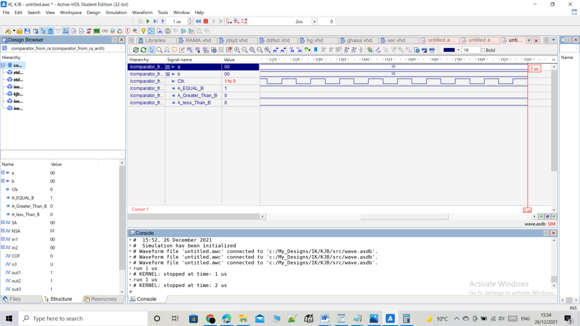

Figure simulation stage 1 c

Simulation for stage 2 comparator:

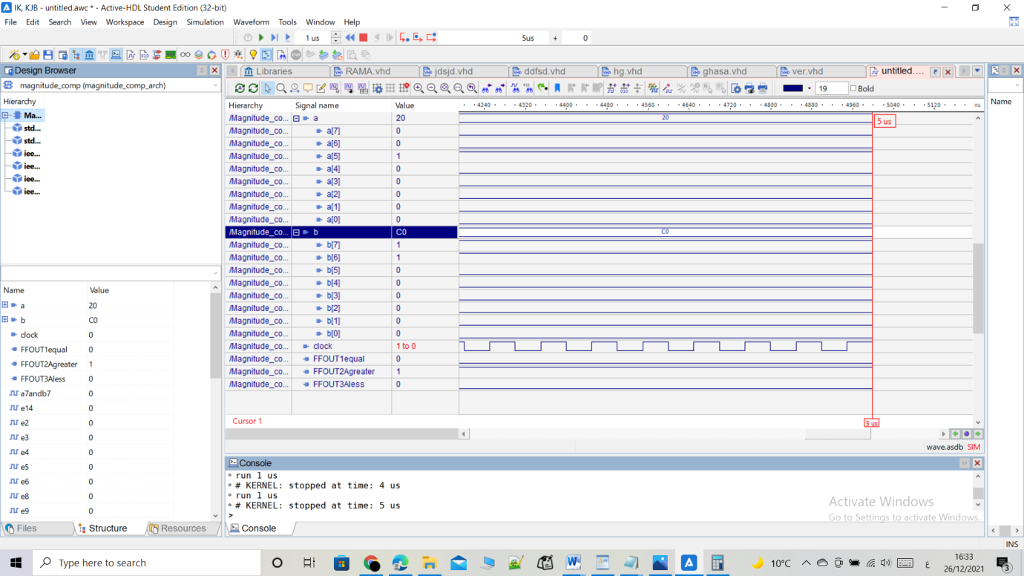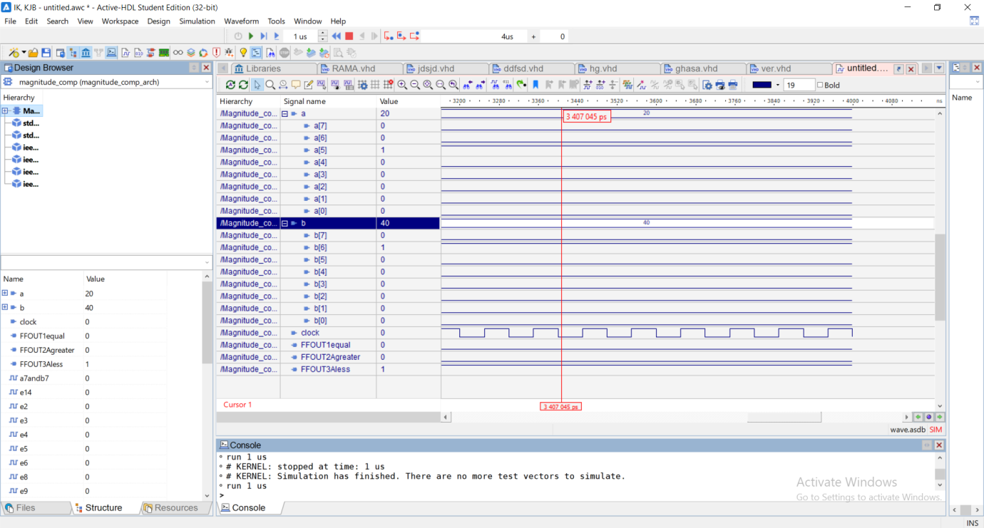

Figure simulation stage 2a

Figure simulation stage 2b

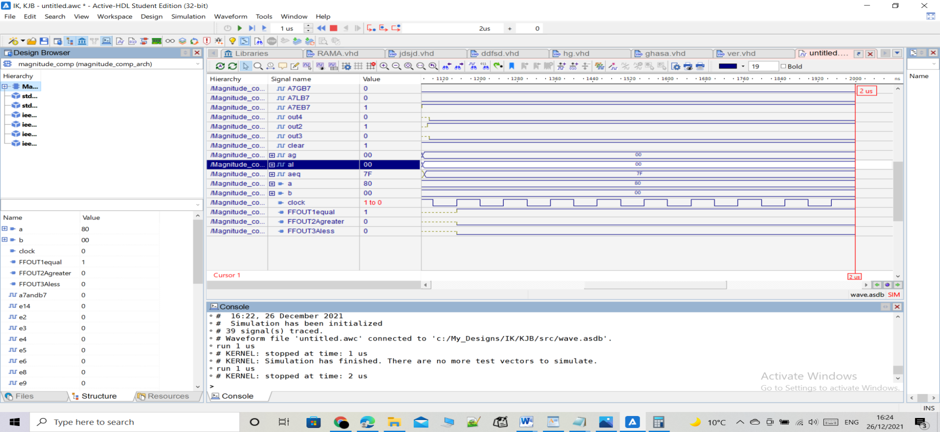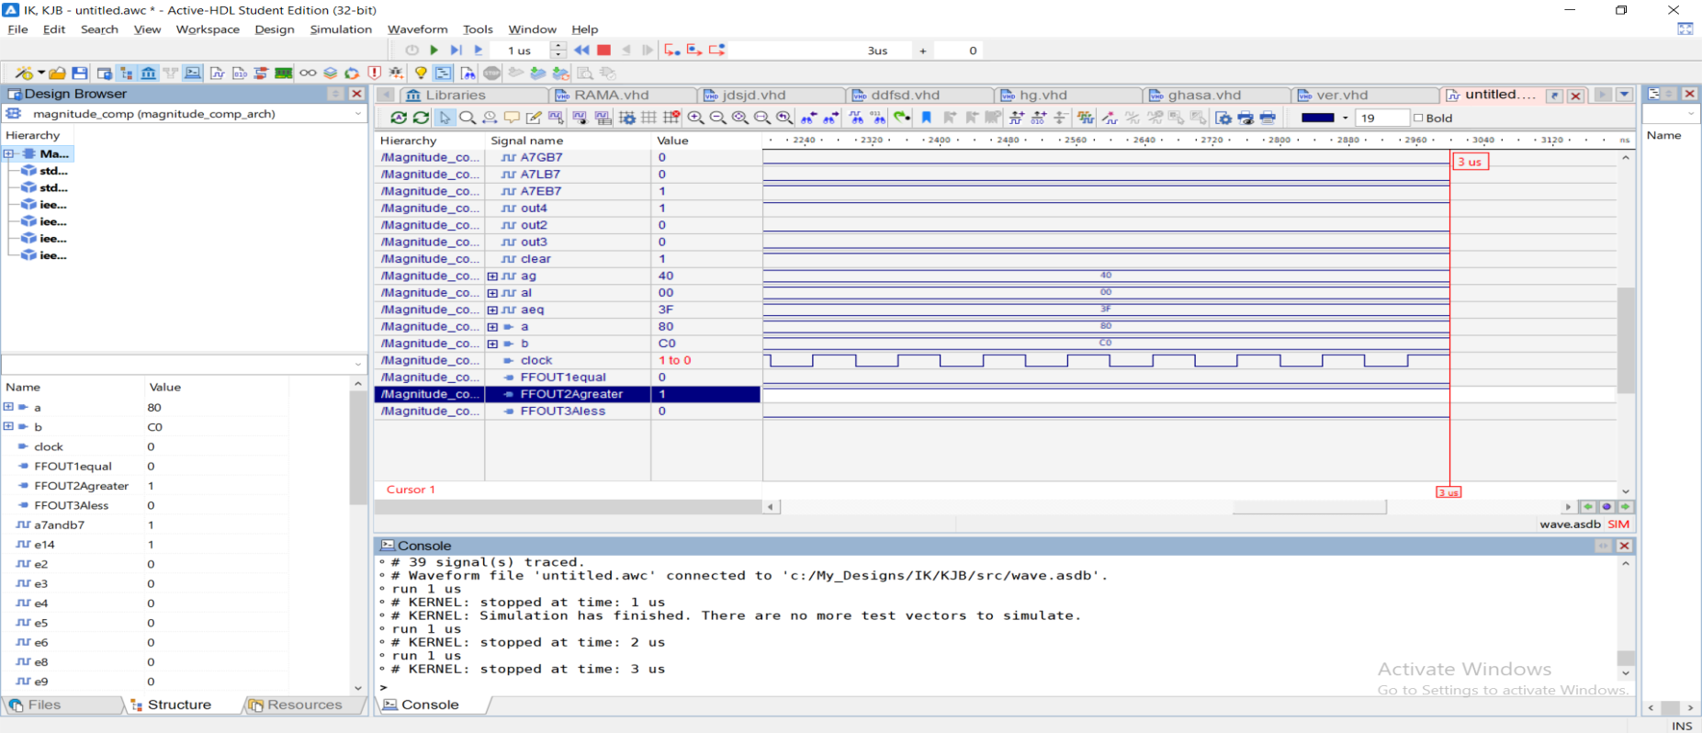

Figure simulation stage 2d

Figure simulation stage 2c

**Functional Verification Results**

Design 1

For the first design, the clock speed was set to be 112ns. Figure 22 shows that the Result Analyzer did not detect any error for the first design (comparator from carry ripple adder).

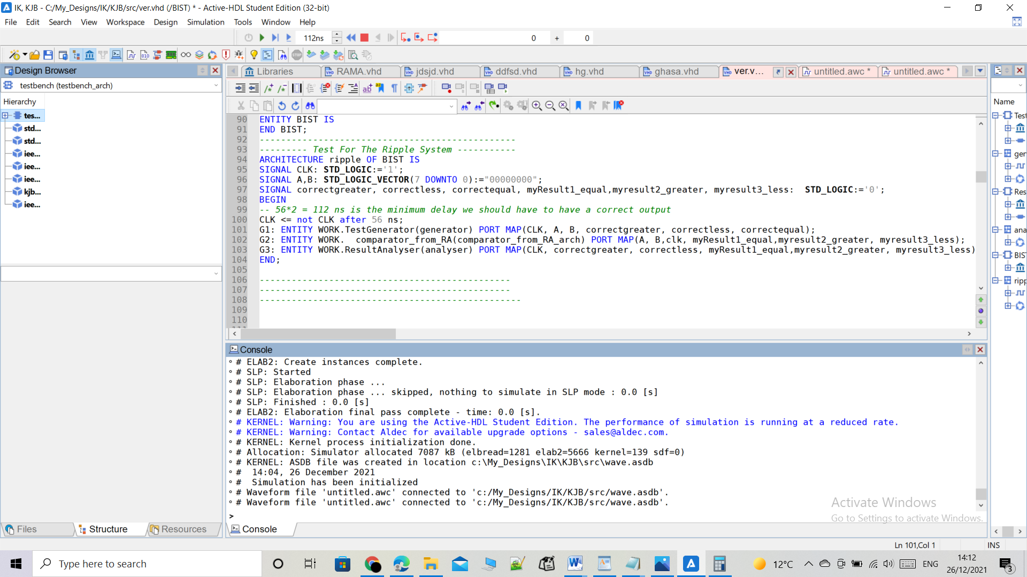

Figure CLOCK

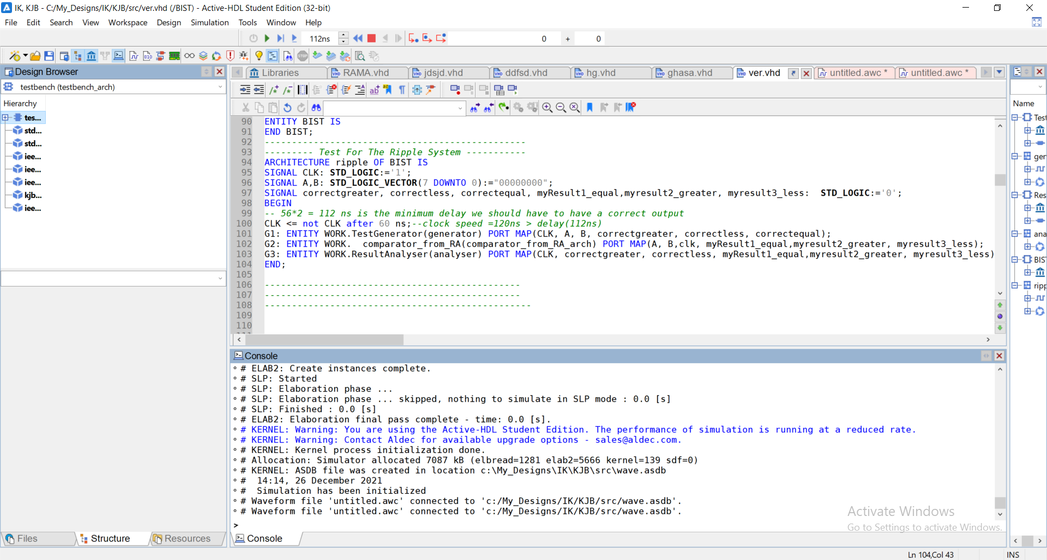

Figure RUNNING NO ERRORS

Also when the clock speed was set to be 120ns. Figure 23 shows that the Result Analyzer did not detect any error :

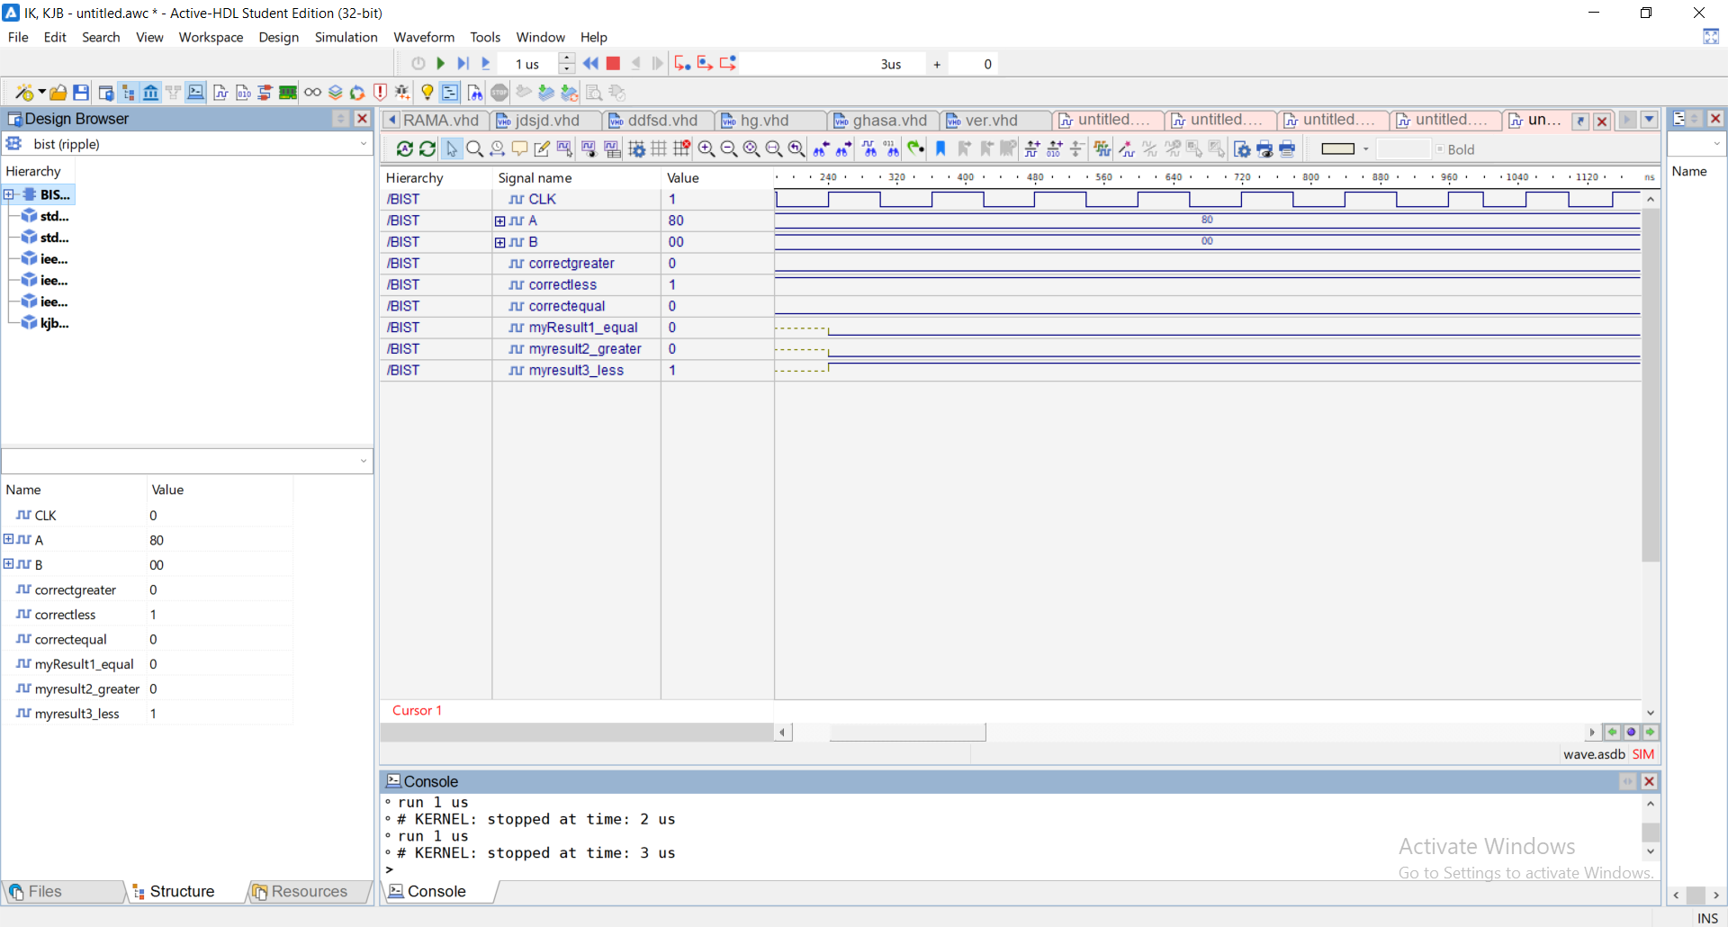

Figure ALSO RUNNING NO ERRORS

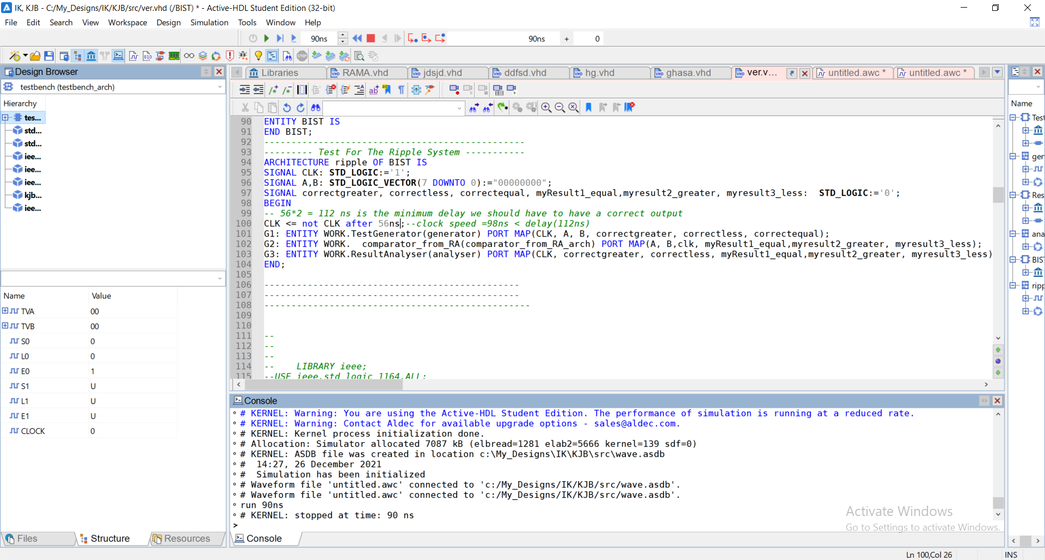

Figure ANOTHER PIC FOR RUNNING WITH NO ERRORS

From calculations before, in time delay figure, I found that the delay for design 1(stage 1) is 112n.

Note that, in the code, the clock parameter was set to be inverted every 56 ns. By setting it to 56ns, each cycle will require 56ns x 2 = 112ns (the parameter ‘clock’ equals half the clock speed).

From figure 4-1 it is clear that the simulation time reached around 100ms which is enough for the test generator to test the whole test vectors that are 2^15= 32 768 vectors

In the next case, the clock speed was set to 92ns. Figure 24 shows the simulation result.

It could be seen from figure bellow that, when the clock speed was faster than the delay, errors were detected.

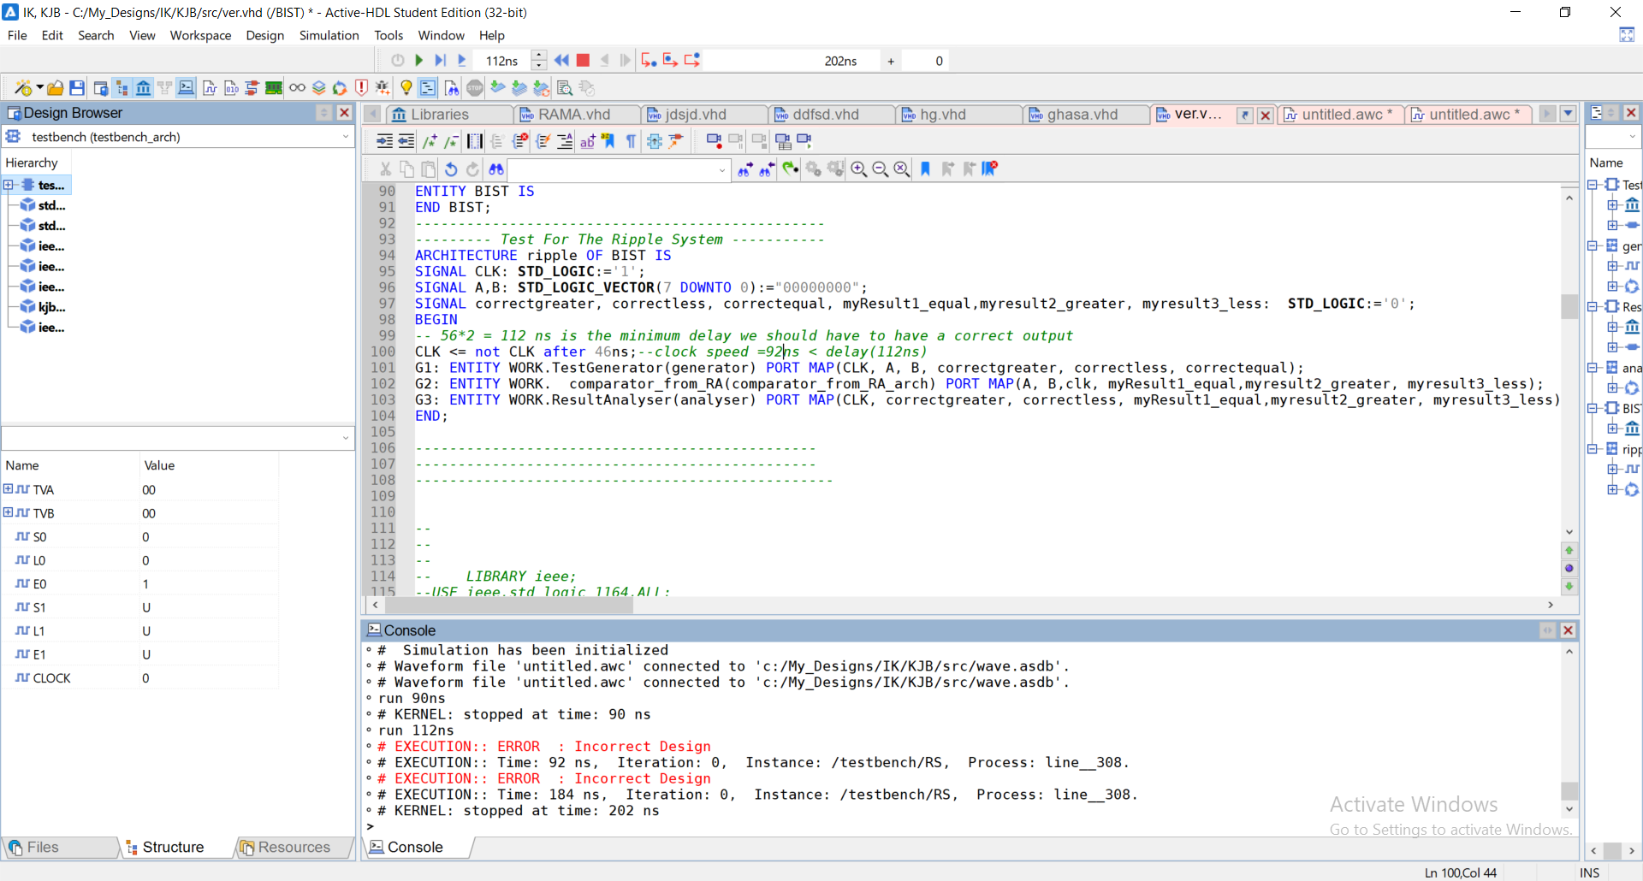

Figure ERRORS DITECTED

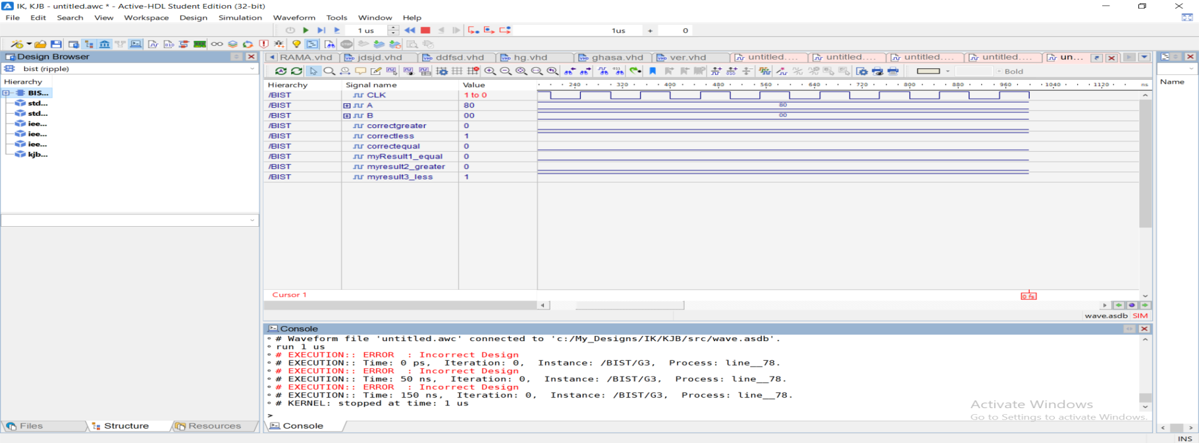

Figure ERRORS DETECTED B

For the next case, the clock speed was reset to the previous value (120ns), an intended fault was done in the adder design. An xor gate was replaced by and gate. The result of the simulation is shown in figure 25

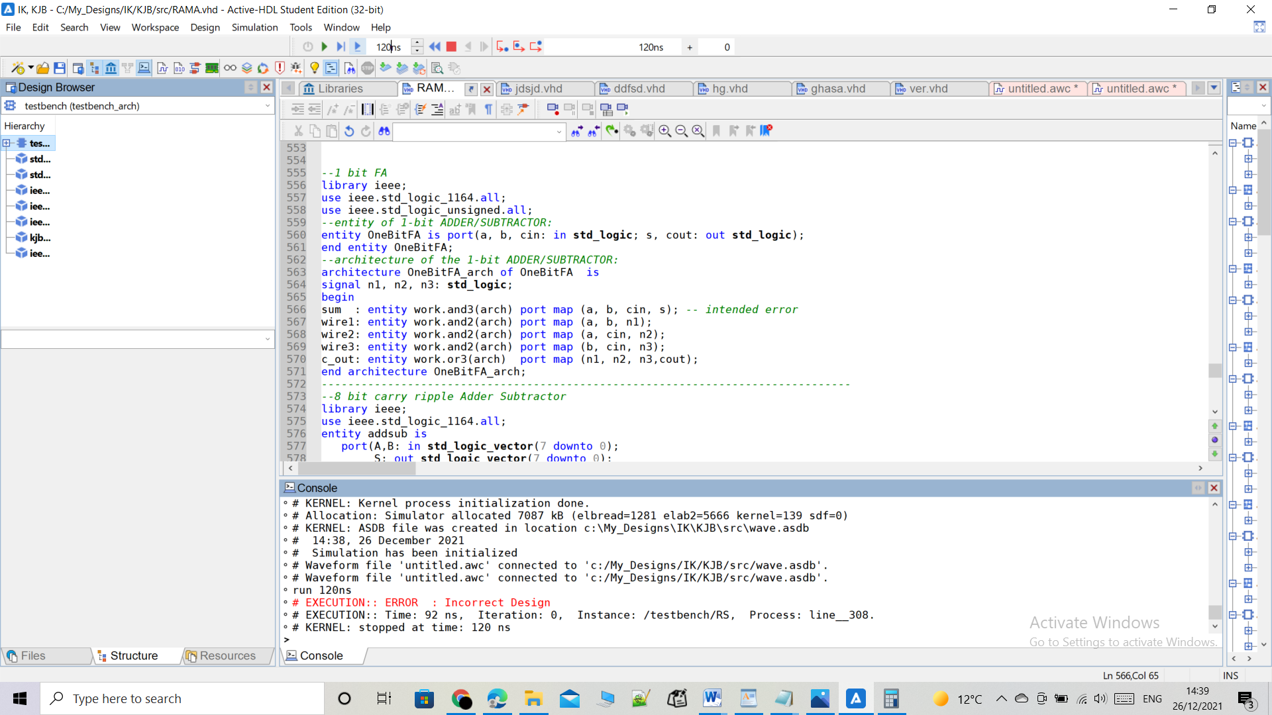

Figure ERRORS DETECTED C

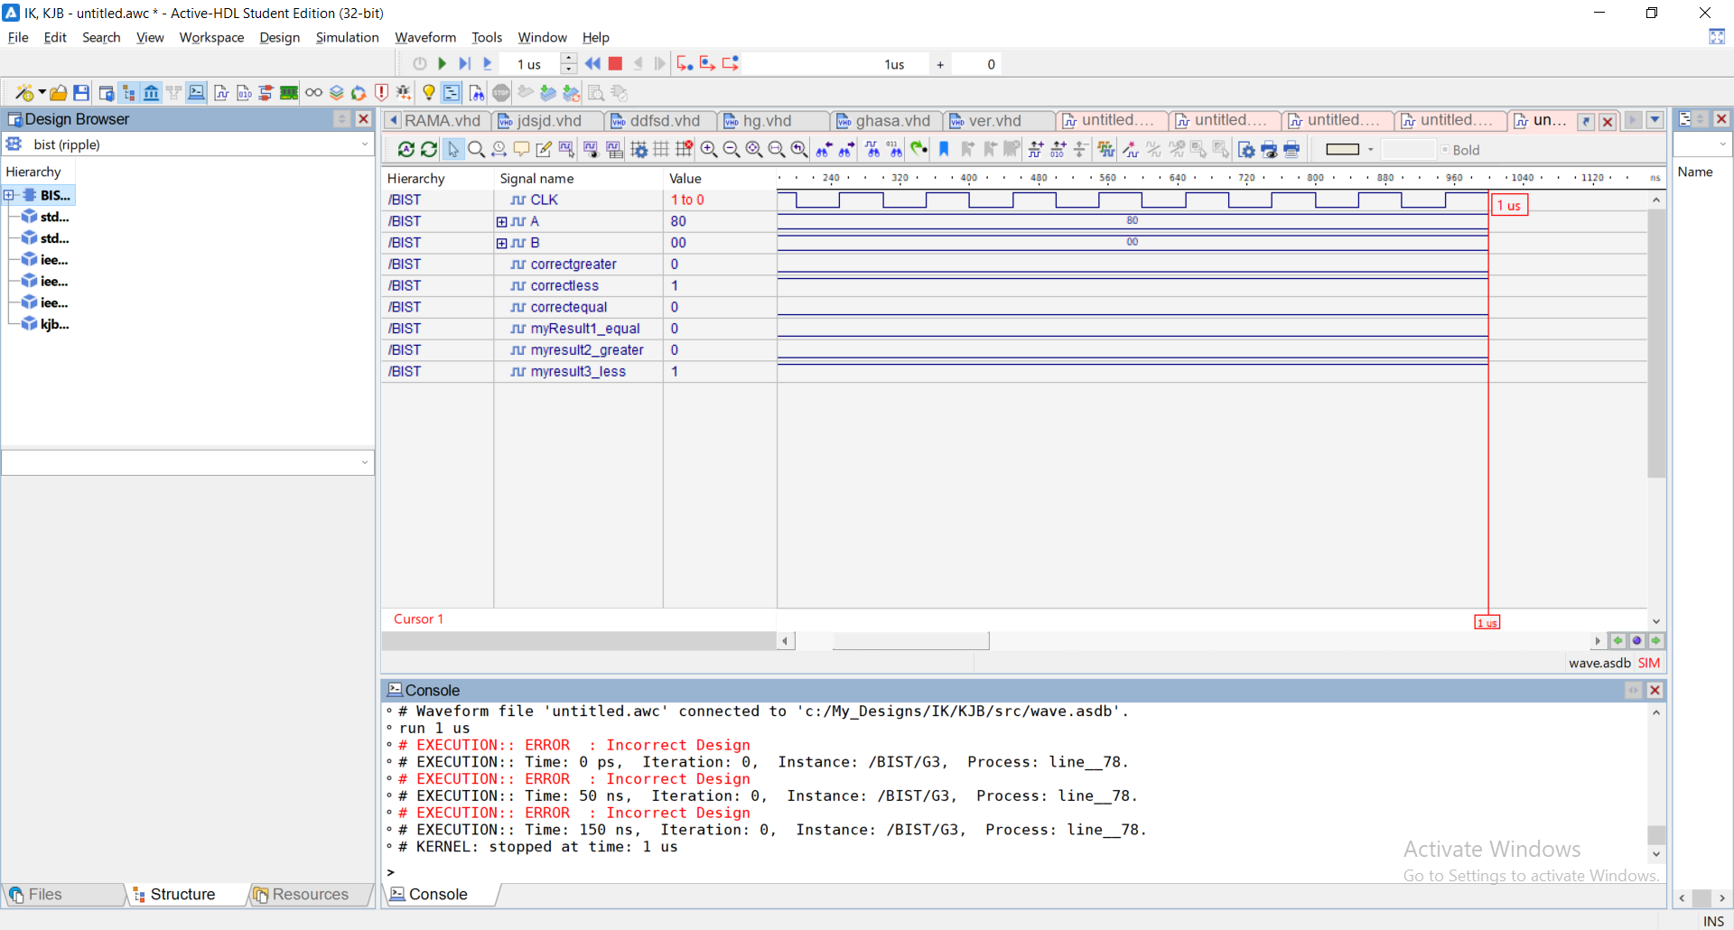As you can see the errors were detected because of the fault occurred in the full adder.

Figure ERRORS DETECTED D

Without the error :

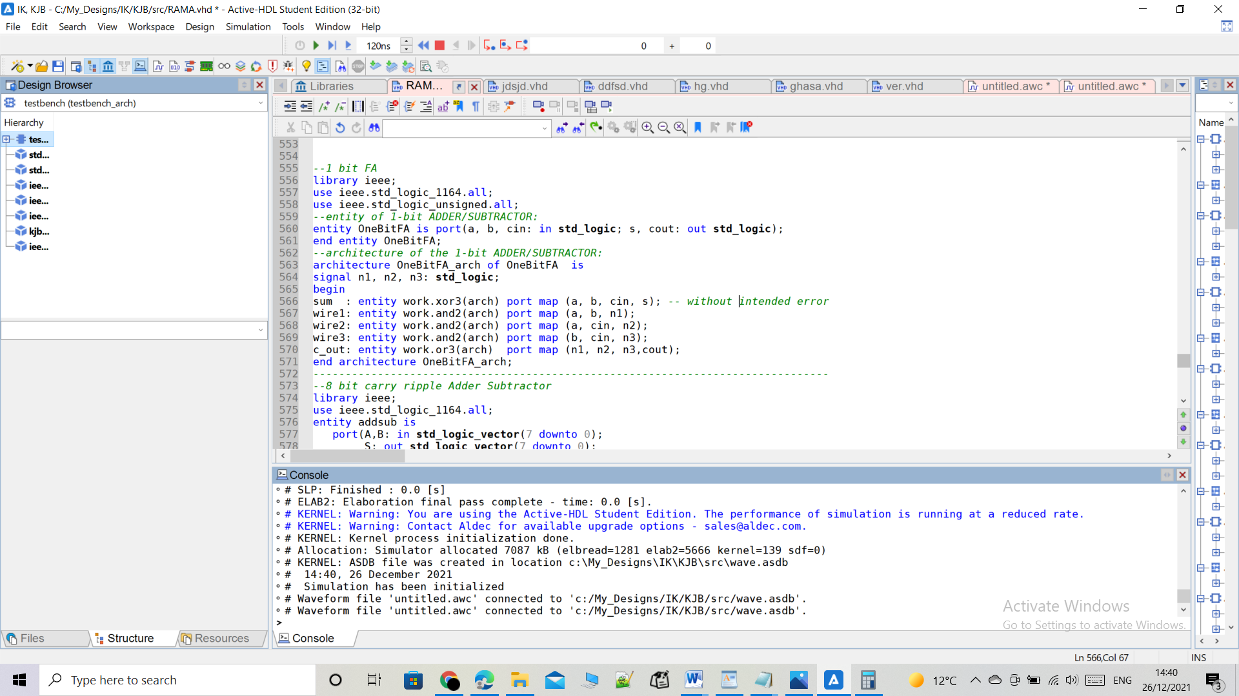

Figure WITHOUT ERRORS

Design 2

For the second design, the clock speed was set to be 150ns. Figure 28 shows that the Result Analyzer did not detect any error for the second design (8 bit magnitude comparator)

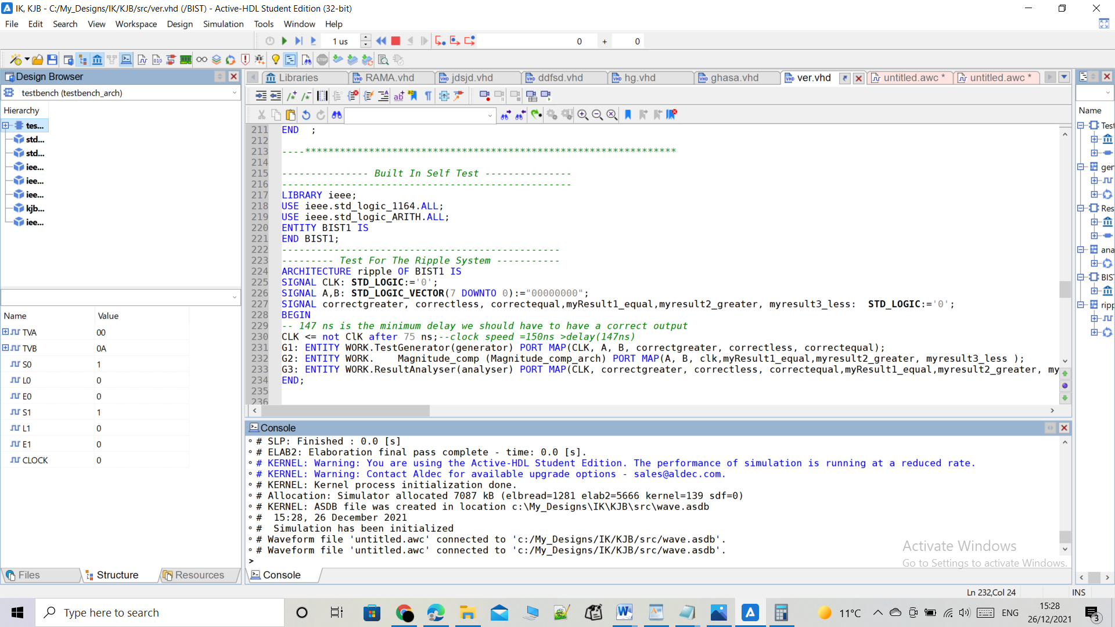

Figure RUNNING WITHOUT ERRORS s2

From calculations before, in a picture I added in Michanasim, I found that the minimum delay for design 2(stage 2) is 147ns.

Note that, in the code, the clock parameter was set to be inverted every 75ns. By setting it to 75ns, each cycle will require 75ns x 2 = 150ns (the parameter ‘clock’ equals half the clock speed). From figure 4-4 it is clear that the simulation time reached around 55ms which is enough for the test generator to test the whole test vectors that are 2^15= 32 768 vectors

In the next case, the clock speed was set to 130ns. Figure 29 shows the simulation result

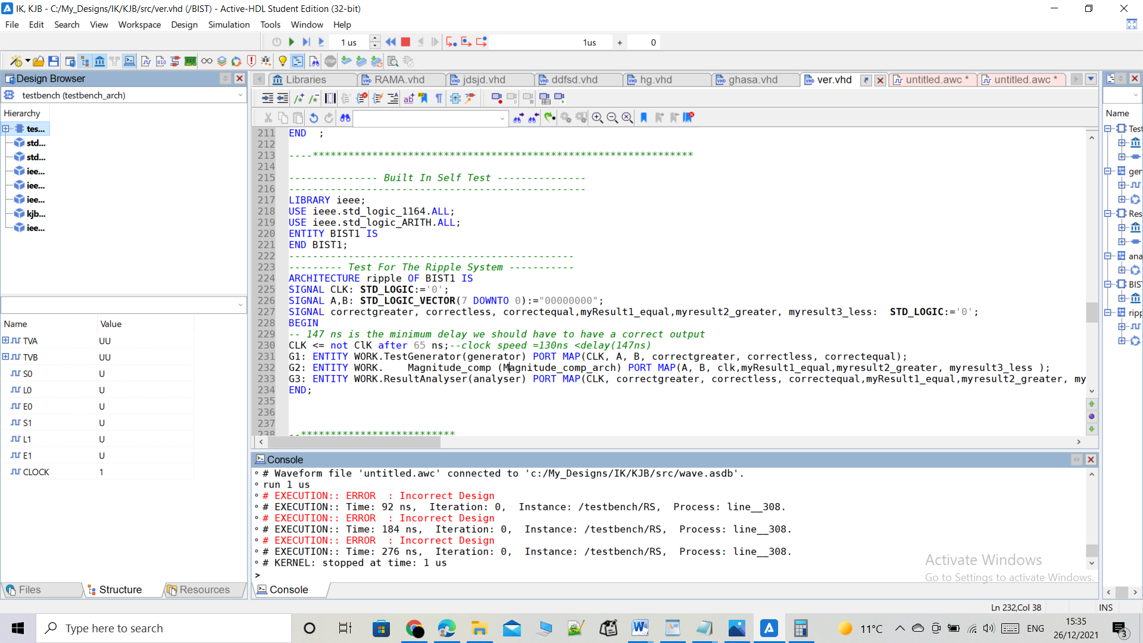

Figure RUNNING WITH ERRORS S2

It could be seen that, when the clock speed was faster than the delay, errors were detected.

For the next case, the clock speed was reset to the previous value (150ns), an intended fault was done in the 1 bit comparator design. An AND gate was replaced by OR gate. The result of the simulation is shown in figure 30.

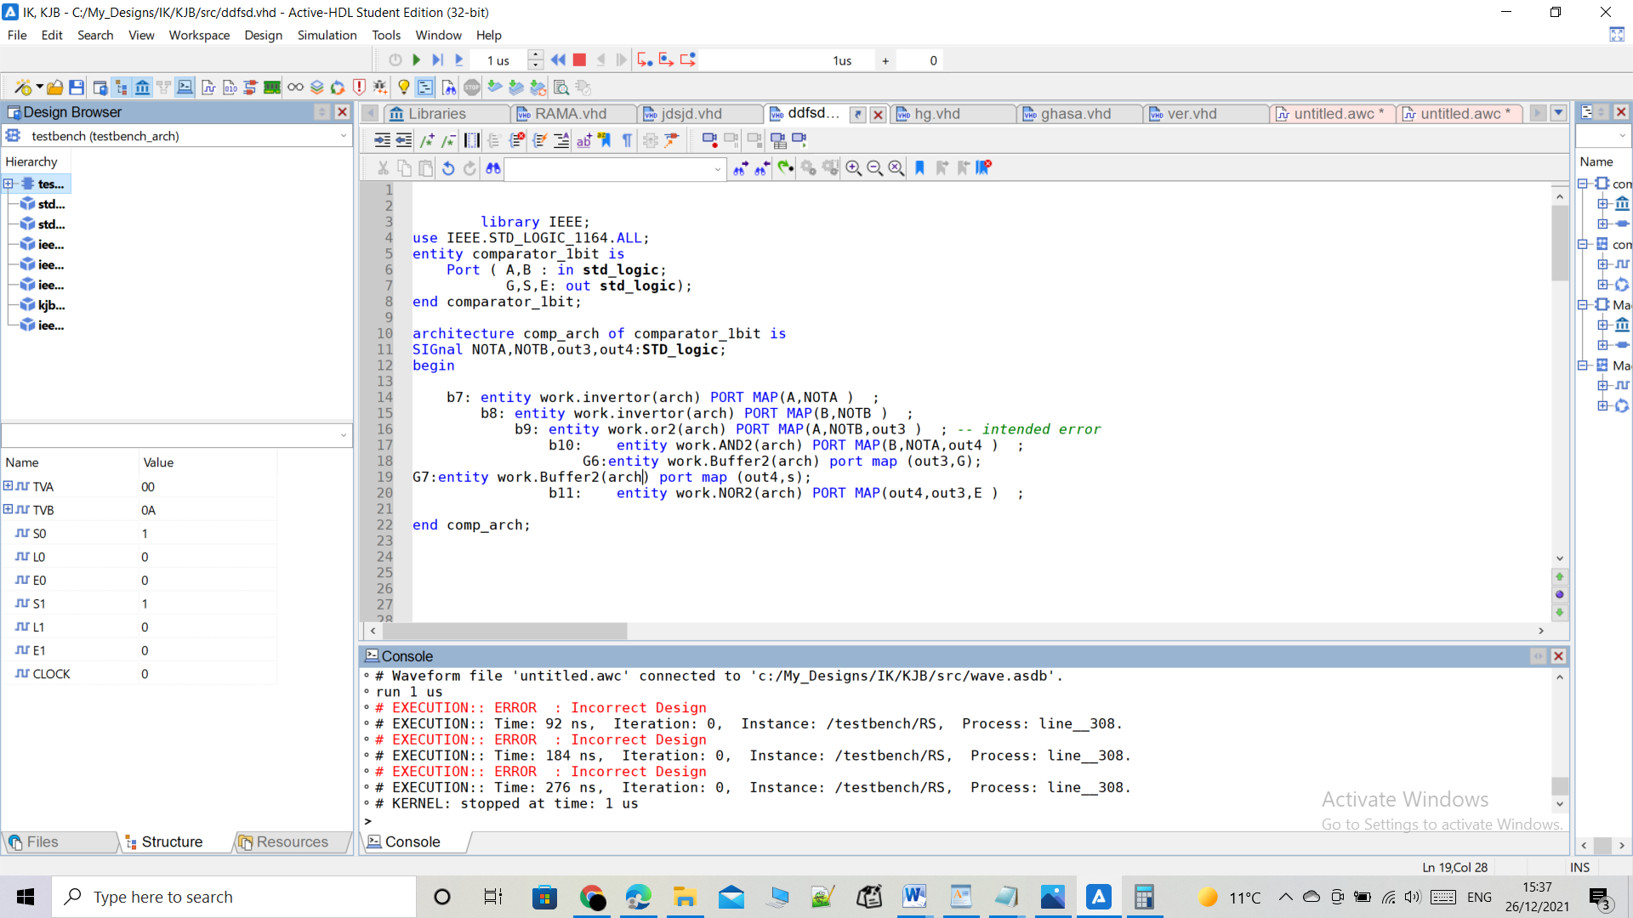

Figure RUNNING WITH ERRORS S2 A

It could be seen that errors were detected due to the fault in the 1 bit comparator.

To conclude, comparator from ripple adder has time delay smaller than that which is built as signed magnitude comparator.

In the end, the two designs were connected with input and output flip-flops, in order to operate the two designs in a synchronous way using an input clock. Where the clock must slower that the maximum delay of each design. For example, for the first design, the clock speed must be slower than 112ns, whether the second design, must be slower than 147ns.

**Some figures from code verification simulation:**

**Notice that the (expected answer equal my answer) in each**

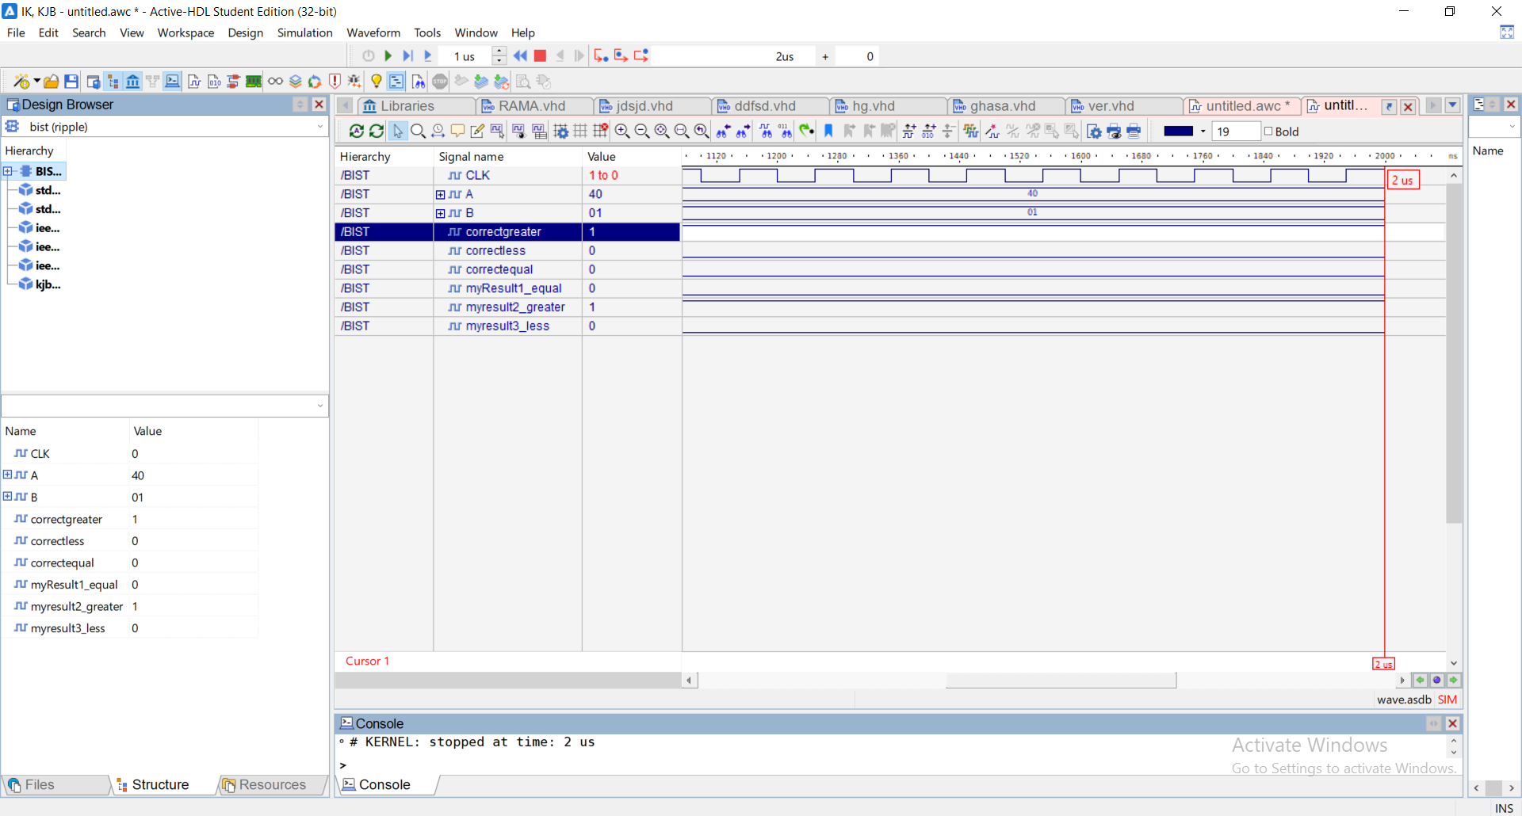**From verification for stage 1**:

Figure SIMULATION FOR VIRIFECTION STAGE 1

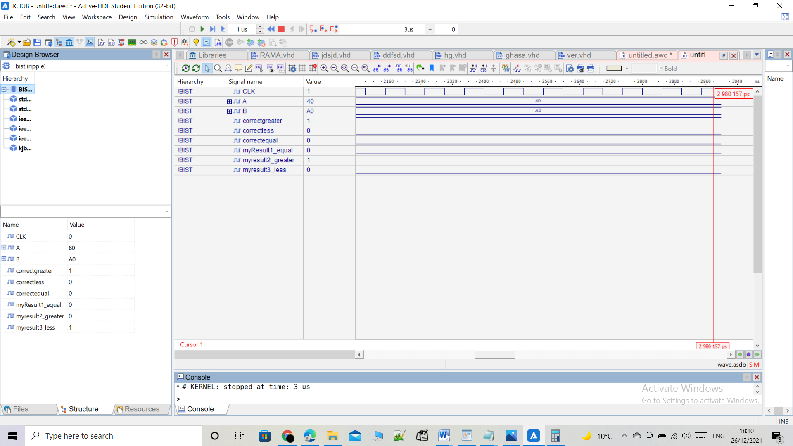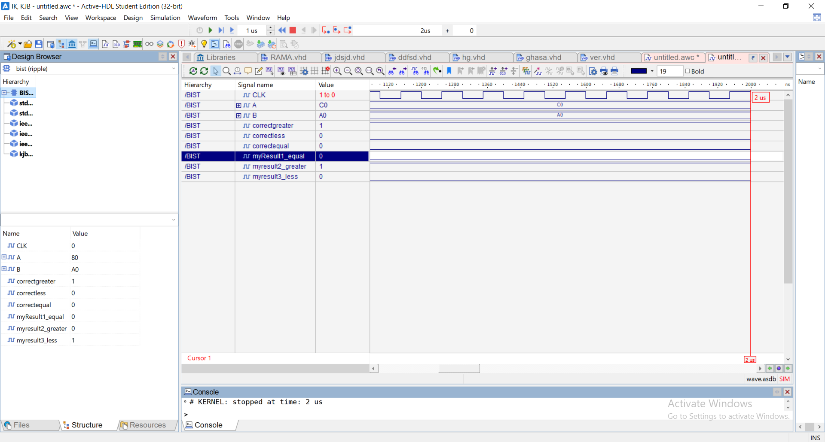

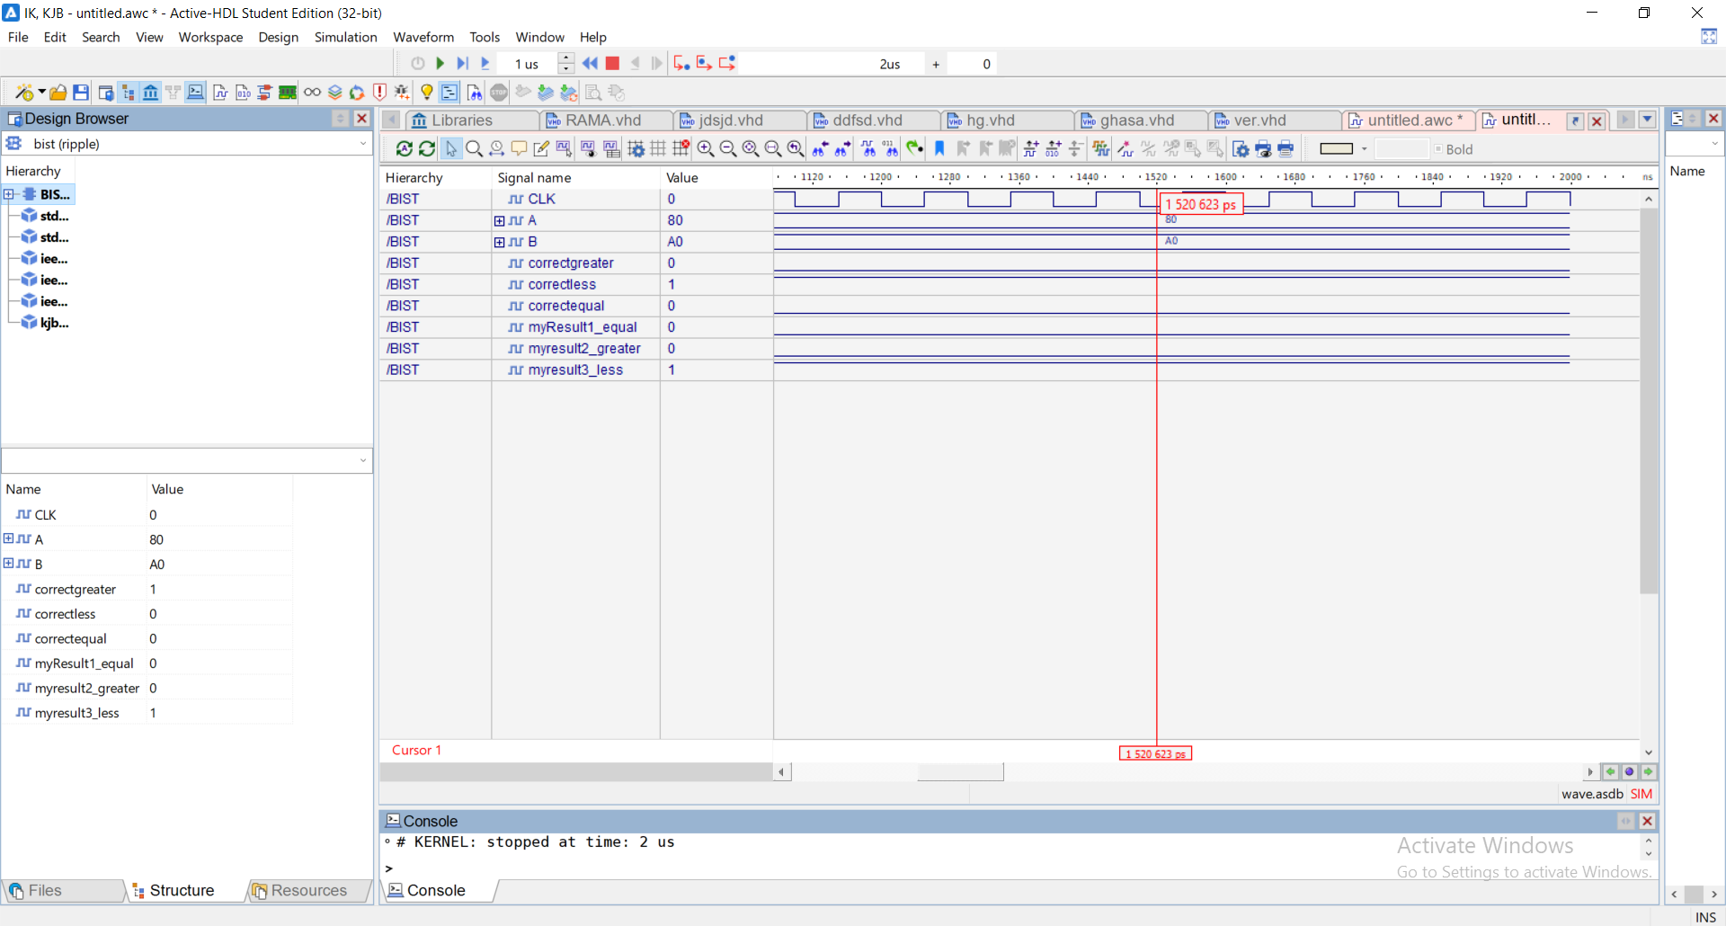

From verification for stage 2:

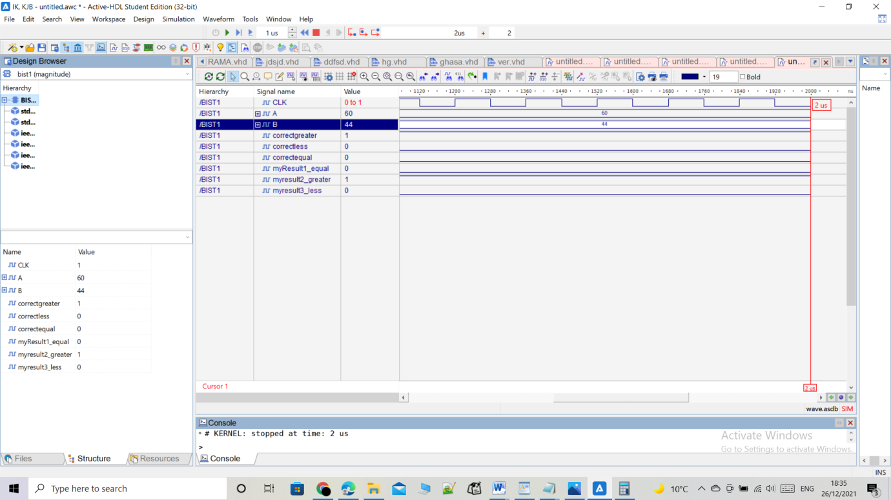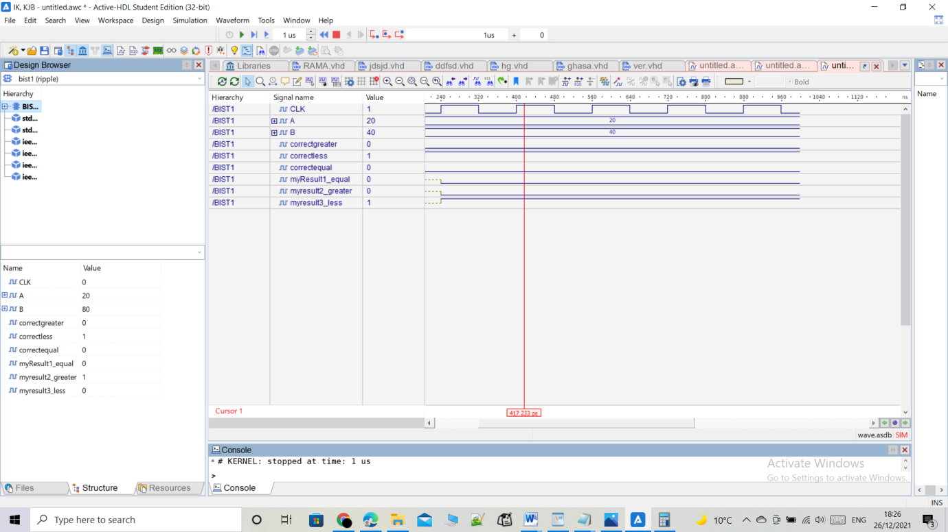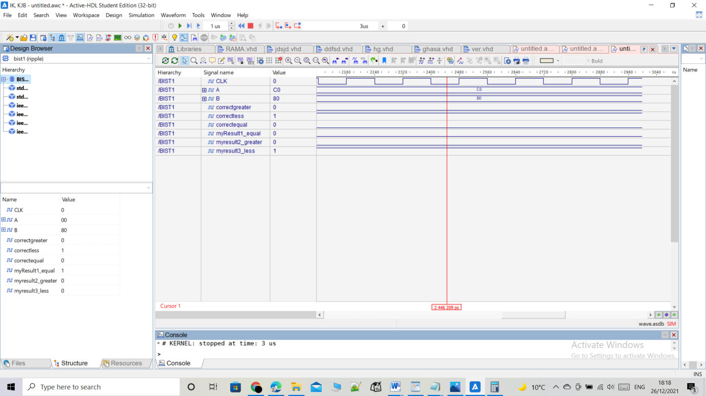

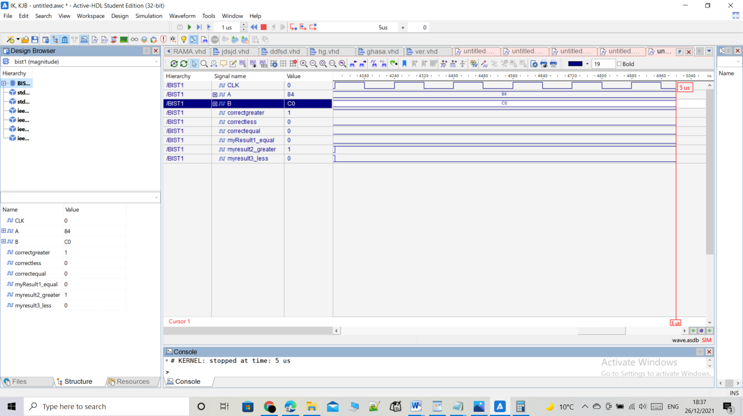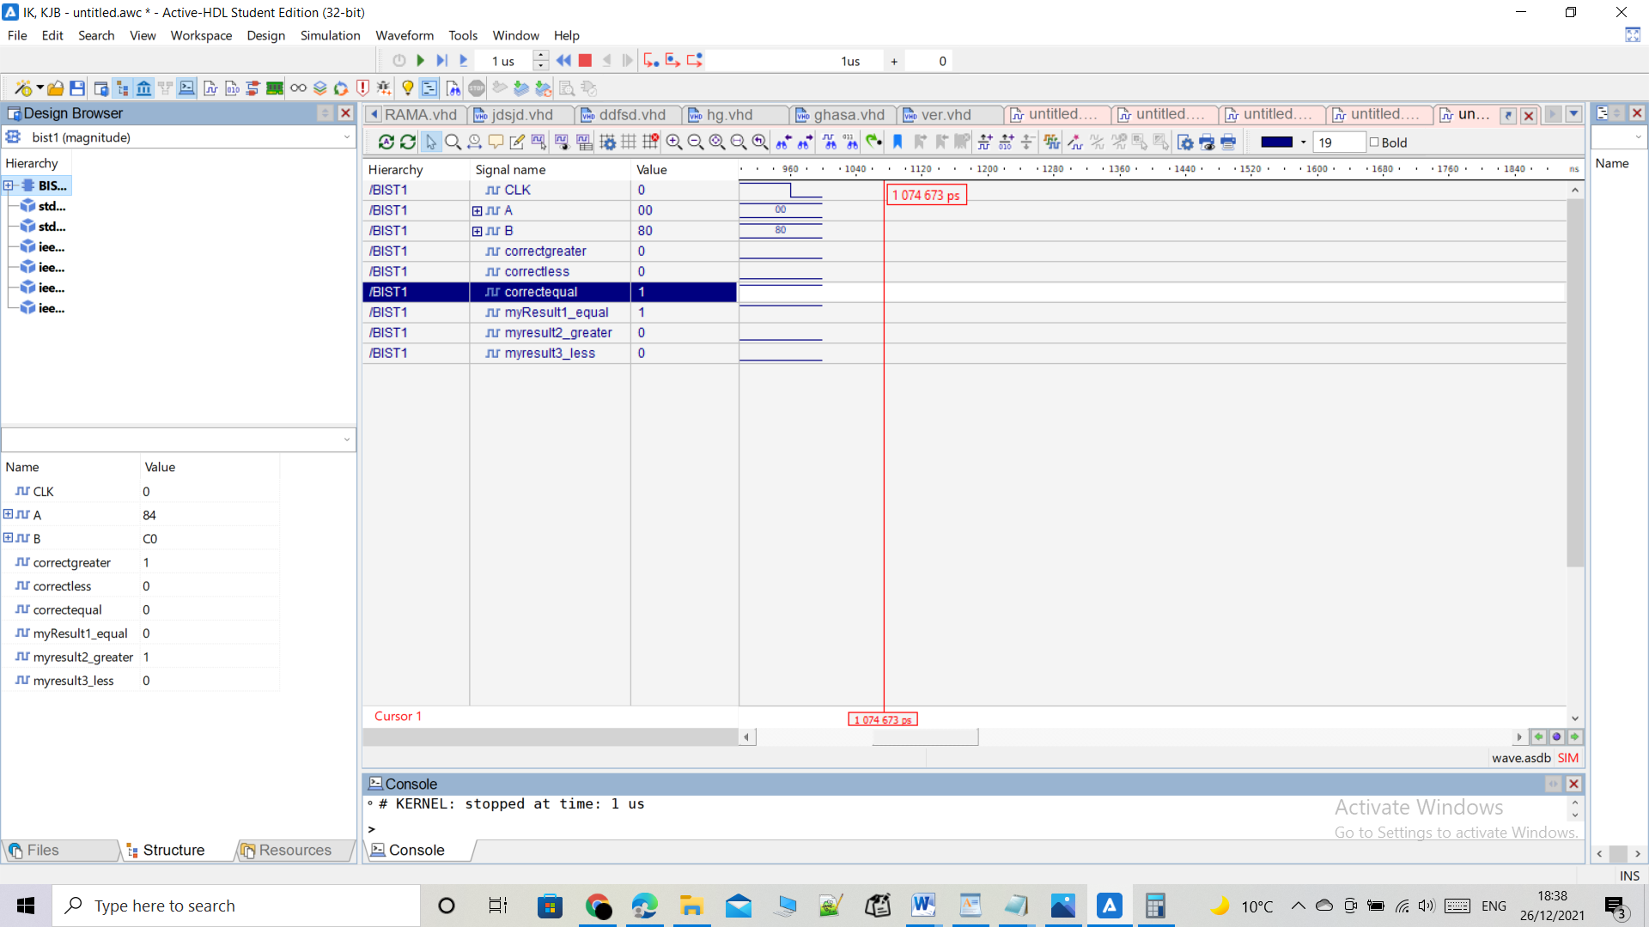

Figure SIMULATION FOR VIRIFECATION STAGE 2

# Conclusion and Future works

The results that were obtained from the previous procedures agree with the theoretical results.I successfully designed a 8-bit comparator in two ways, and then complete a code for functional verification. I noticed how the built in test is useful in check the accuracy of the outputs. this project was helpful in learning more about the types of adders such as carry loo-ahead adder and why it is more preferable. Also it was helpful in learning how to build comparator from adder and how to build comparator for signed numbers. The more important thing that was learnt from this project was that the VHDL programming skills were improved significantly. This may help in the future

.

# References

<https://dl.acm.org/doi/10.1145/266021.266033>

<https://www.quora.com/How-does-a-carry-lookahead-adder-work>

<https://electronics.stackexchange.com/questions/519178/boolean-algebra-how-do-i-implenent-a-4-bit-signed-comparator>

<https://www.electronics-tutorials.ws/combination/comb_8.html>

Appendix :

----------------------------AND GATES-------------------------------------------

**LIBRARY** ieee;

**USE** ieee.std_logic_1164.**ALL**;

--two inputs AND gate:

**ENTITY** and2 **IS**

**PORT** (

x, y : **IN** **std_logic**;

z : **OUT** **std_logic**

);

**END** **ENTITY** and2;

**ARCHITECTURE** arch **OF** and2 **IS**

**BEGIN**

z <= (x **AND** y) **AFTER** 7ns;

**END** **ARCHITECTURE** arch;

--------------------------------------------------------------------------------

**LIBRARY** ieee;

**USE** ieee.std_logic_1164.**ALL**;

--three inputs AND gate:

**ENTITY** and3 **IS**

**PORT** (

w, x, y : **IN** **std_logic**;

z : **OUT** **std_logic**

);

**END** **ENTITY** and3;

**ARCHITECTURE** arch **OF** and3 **IS**

**BEGIN**

z <= (w **AND** x **AND** y) **AFTER** 7ns;

**END** **ARCHITECTURE** arch;

--------------------------------------------------------------------------------

**LIBRARY** ieee;

**USE** ieee.std_logic_1164.**ALL**;

--four inputs AND gate:

**ENTITY** and4 **IS**

**PORT** (

n, w, x, y : **IN** **std_logic**;

z : **OUT** **std_logic**

);

**END** **ENTITY** and4;

**ARCHITECTURE** arch **OF** and4 **IS**

**BEGIN**

z <= (n **AND** w **AND** x **AND** y) **AFTER** 7ns;

**END** **ARCHITECTURE** arch;

--------------------------------------------------------------------------------

**LIBRARY** ieee;

**USE** ieee.std_logic_1164.**ALL**;

--five inputs AND gate:

**ENTITY** and5 **IS**

**PORT** (

m, n, w, x, y : **IN** **std_logic**;

z : **OUT** **std_logic**

);

**END** **ENTITY** and5;

**ARCHITECTURE** arch **OF** and5 **IS**

**BEGIN**

z <= (m **AND** n **AND** w **AND** x **AND** y) **AFTER** 7ns;

**END** **ARCHITECTURE** arch;

--------------------------------------------------------------------------------

**LIBRARY** ieee;

**USE** ieee.std_logic_1164.**ALL**;

--6 inputs AND gate:

**ENTITY** and6 **IS**

**PORT** (

m, n, w, x, y, l : **IN** **std_logic**;

z : **OUT** **std_logic**

);

**END** **ENTITY** and6;

**ARCHITECTURE** arch **OF** and6 **IS**

**BEGIN**

z <= (m **AND** n **AND** w **AND** x **AND** y **AND** l) **AFTER** 7ns;

**END** **ARCHITECTURE** arch;

--------------------------------------------------------------------------------

**LIBRARY** ieee;

**USE** ieee.std_logic_1164.**ALL**;

--7 inputs AND gate:

**ENTITY** and7 **IS**

**PORT** (

m, n, w, x, y, l, h : **IN** **std_logic**;

z : **OUT** **std_logic**

);

**END** **ENTITY** and7;

**ARCHITECTURE** arch **OF** and7 **IS** **BEGIN**

z <= (m **AND** n **AND** w **AND** x **AND** y **AND** l **AND** h) **AFTER** 7ns;

**END** **ARCHITECTURE** arch;

--------------------------------------------------------------------------------

**LIBRARY** ieee;

**USE** ieee.std_logic_1164.**ALL**;

--8 inputs AND gate:

**ENTITY** and8 **IS**

**PORT** (

m, n, w, x, y, l, h, i : **IN** **std_logic**;

z : **OUT** **std_logic**

);

**END** **ENTITY** and8;

**ARCHITECTURE** arch **OF** and8 **IS** **BEGIN**

z <= (m **AND** n **AND** w **AND** x **AND** y **AND** l **AND** h **AND** i) **AFTER** 7ns;

**END** **ARCHITECTURE** arch;

--------------------------------------------------------------------------------

**LIBRARY** ieee;

**USE** ieee.std_logic_1164.**ALL**;

--9 inputs AND gate:

**ENTITY** and9 **IS**

**PORT** (

m, n, w, x, y, l, h, i, s : **IN** **std_logic**;

z : **OUT** **std_logic**

);

**END** **ENTITY** and9;

**ARCHITECTURE** arch **OF** and9 **IS** **BEGIN**

z <= (m **AND** n **AND** w **AND** x **AND** y **AND** l **AND** h **AND** i **AND** s) **AFTER** 7ns;

**END** **ARCHITECTURE** arch;

--------------------------------------------------------------------------------

**LIBRARY** ieee;

**USE** ieee.std_logic_1164.**ALL**;

--two inputs XNOR gate:

**ENTITY** xnor2 **IS**

**PORT** (

x, y : **IN** **std_logic**;

z : **OUT** **std_logic**

);

**END** **ENTITY** xnor2;

**ARCHITECTURE** arch **OF** xnor2 **IS**

**BEGIN**

z <= (x **XNOR** y) **AFTER** 9ns;

**END** **ARCHITECTURE** arch;

----------------------------OR GATES--------------------------------------------

**LIBRARY** ieee;

**USE** ieee.std_logic_1164.**ALL**;

--two inputs OR gate:

**ENTITY** OR2 **IS**

**PORT** (

x, y : **IN** **std_logic**;

z : **OUT** **std_logic**

);

**END** **ENTITY** OR2;

**ARCHITECTURE** arch **OF** OR2 **IS**

**BEGIN**

z <= (x **OR** y) **AFTER** 7ns;

**END** **ARCHITECTURE** arch;

--------------------------------------------------------------------------------

**LIBRARY** ieee;

**USE** ieee.std_logic_1164.**ALL**;

--three inputs OR gate:

**ENTITY** or3 **IS**

**PORT** (

w, x, y : **IN** **std_logic**;

z : **OUT** **std_logic**

);

**END** **ENTITY** or3;

**ARCHITECTURE** arch **OF** or3 **IS**

**BEGIN**

z <= (w **OR** x **OR** y) **AFTER** 7ns;

**END** **ARCHITECTURE** arch;

--------------------------------------------------------------------------------

**LIBRARY** ieee;

**USE** ieee.std_logic_1164.**ALL**;

--four inputs OR gate:

**ENTITY** or4 **IS**

**PORT** (

n, w, x, y : **IN** **std_logic**;

z : **OUT** **std_logic**

);

**END** **ENTITY** or4;

**ARCHITECTURE** arch **OF** or4 **IS** **BEGIN**

z <= (n **OR** w **OR** x **OR** y) **AFTER** 7ns;

**END** **ARCHITECTURE** arch;

--------------------------------------------------------------------------------

**LIBRARY** ieee;

**USE** ieee.std_logic_1164.**ALL**;

--five inputs OR gate:

**ENTITY** or5 **IS**

**PORT** (

m, n, w, x, y : **IN** **std_logic**;

z : **OUT** **std_logic**

);

**END** **ENTITY** or5;

**ARCHITECTURE** arch **OF** or5 **IS** **BEGIN**

z <= (m **OR** n **OR** w **OR** x **OR** y) **AFTER** 7ns;

**END** **ARCHITECTURE** arch;

--------------------------------------------------------------------------------

**LIBRARY** ieee;

**USE** ieee.std_logic_1164.**ALL**;

--6 inputs OR gate:

**ENTITY** or6 **IS**

**PORT** (

m, n, w, x, y, l : **IN** **std_logic**;

z : **OUT** **std_logic**

);

**END** **ENTITY** or6;

**ARCHITECTURE** arch **OF** or6 **IS** **BEGIN**

z <= (m **OR** n **OR** w **OR** x **OR** y **OR** l) **AFTER** 7ns;

**END** **ARCHITECTURE** arch;

--------------------------------------------------------------------------------

**LIBRARY** ieee;

**USE** ieee.std_logic_1164.**ALL**;

--7 inputs OR gate:

**ENTITY** or7 **IS**

**PORT** (

m, n, w, x, y, l, h : **IN** **std_logic**;

z : **OUT** **std_logic**

);

**END** **ENTITY** or7;

**ARCHITECTURE** arch **OF** or7 **IS** **BEGIN**

z <= (m **OR** n **OR** w **OR** x **OR** y **OR** l **OR** h) **AFTER** 7ns;

**END** **ARCHITECTURE** arch;

--------------------------------------------------------------------------------

**LIBRARY** ieee;

**USE** ieee.std_logic_1164.**ALL**;

--8 inputs OR gate:

**ENTITY** or8 **IS**

**PORT** (

m, n, w, x, y, l, h, i : **IN** **std_logic**;

z : **OUT** **std_logic**

);

**END** **ENTITY** or8;

**ARCHITECTURE** arch **OF** or8 **IS** **BEGIN**

z <= (m **OR** n **OR** w **OR** x **OR** y **OR** l **OR** h **OR** i) **AFTER** 7ns;

**END** **ARCHITECTURE** arch;

--------------------------------------------------------------------------------

**LIBRARY** ieee;

**USE** ieee.std_logic_1164.**ALL**;

--9 inputs OR gate:

**ENTITY** or9 **IS**

**PORT** (

m, n, w, x, y, l, h, i, s : **IN** **std_logic**;

z : **OUT** **std_logic**

);

**END** **ENTITY** or9;

**ARCHITECTURE** arch **OF** or9 **IS** **BEGIN**

z <= (m **OR** n **OR** w **OR** x **OR** y **OR** l **OR** h **OR** i **OR** s) **AFTER** 7ns;

**END** **ARCHITECTURE** arch;

----------------------------XOR GATES-------------------------------------------

**LIBRARY** ieee;

**USE** ieee.std_logic_1164.**ALL**;

--two inputs XOR gate:

**ENTITY** XOR2 **IS**

**PORT** (

x, y : **IN** **std_logic**;

z : **OUT** **std_logic**

);

**END** **ENTITY** XOR2;

**ARCHITECTURE** arch **OF** XOR2 **IS**

**BEGIN**

z <= (x **XOR** y) **AFTER** 12ns;

**END** **ARCHITECTURE** arch;

--------------------------------------------------------------------------------

**LIBRARY** ieee;

**USE** ieee.std_logic_1164.**ALL**;

--three inputs XOR gate:

**ENTITY** xor3 **IS**

**PORT** (

w, x, y : **IN** **std_logic**;

z : **OUT** **std_logic**

);

**END** **ENTITY** xor3;

**ARCHITECTURE** arch **OF** xor3 **IS**

**BEGIN**

z <= (w **XOR** x **XOR** y) **AFTER** 12ns;

**END** **ARCHITECTURE** arch;

----------------------------NOR GATES-------------------------------------------

**LIBRARY** ieee;

**USE** ieee.std_logic_1164.**ALL**;

--two inputs NOR gate:

**ENTITY** nor2 **IS**

**PORT** (

x, y : **IN** **std_logic**;

z : **OUT** **std_logic**

);

**END** **ENTITY** nor2;

**ARCHITECTURE** arch **OF** nor2 **IS**

**BEGIN**

z <= (x **NOR** y) **AFTER** 5ns;

**END** **ARCHITECTURE** arch;

--------------------------------------------------------------------------------

**LIBRARY** ieee;

**USE** ieee.std_logic_1164.**ALL**;

--8 inputs NOR gate:

**ENTITY** nor8 **IS**

**PORT** (

m, n, w, x, y, l, h, i : **IN** **std_logic**;

z : **OUT** **std_logic**

);

**END** **ENTITY** nor8;

**ARCHITECTURE** arch **OF** nor8 **IS**

**BEGIN**

z <= ((**NOT** m) **AND** (**NOT** n) **AND** (**NOT** w) **AND** (**NOT** x) **AND** (**NOT** y) **AND** (**NOT** l) **AND** (**NOT** h) **AND** (**NOT** i)) **AFTER** 7ns;

**END** **ARCHITECTURE** arch;

--------------------------------------------------------------------------------

**LIBRARY** ieee;

**USE** ieee.std_logic_1164.**ALL**;

--two inputs NAND gate:

**ENTITY** nand2 **IS**

**PORT** (

x, y : **IN** **std_logic**;

z : **OUT** **std_logic**

);

**END** **ENTITY** nand2;

**ARCHITECTURE** arch **OF** nand2 **IS**

**BEGIN**

z <= (x **NAND** y) **AFTER** 5ns;

**END** **ARCHITECTURE** arch;

--------------------------------------------------------------------------------

**LIBRARY** ieee;

**USE** ieee.std_logic_1164.**ALL**;

-- BUFFER:

**ENTITY** Buffer2 **IS**

**PORT** (

x : **IN** **std_logic**;

z : **OUT** **std_logic**

);

**END** **ENTITY** Buffer2;

**ARCHITECTURE** arch **OF** Buffer2 **IS**

**BEGIN**

z <= x **AFTER** 2ns;

**END** **ARCHITECTURE** arch;

--------------------------------------------------------------------------------

**LIBRARY** ieee;

**USE** ieee.std_logic_1164.**ALL**;

-- INVERTOR:

**ENTITY** invertor **IS**

**PORT** (

x : **IN** **std_logic**;

z : **OUT** **std_logic**

);

**END** **ENTITY** invertor;

**ARCHITECTURE** arch **OF** invertor **IS**

**BEGIN**

z <= **NOT** x **AFTER** 2ns;

**END** **ARCHITECTURE** arch;

----------------------------------------------------------------------------

--1 bit FA

**LIBRARY** ieee;

**USE** ieee.std_logic_1164.**ALL**;

**USE** ieee.std_logic_unsigned.**ALL**;

--entity of 1-bit ADDER/SUBTRACTOR:

**ENTITY** OneBitFA **IS**

**PORT** (

a, b, cin : **IN** **std_logic**;

s, cout : **OUT** **std_logic**

);

**END** **ENTITY** OneBitFA;

--architecture of the 1-bit ADDER/SUBTRACTOR:

**ARCHITECTURE** OneBitFA_arch **OF** OneBitFA **IS**

**SIGNAL** n1, n2, n3 : **std_logic**;

**BEGIN**

sum : **ENTITY** work.xor3(arch)

**PORT** **MAP**(a, b, cin, s); -- intended error

wire1 : **ENTITY** work.and2(arch)

**PORT** **MAP**(a, b, n1);

wire2 : **ENTITY** work.and2(arch)

**PORT** **MAP**(a, cin, n2);

wire3 : **ENTITY** work.and2(arch)

**PORT** **MAP**(b, cin, n3);

c_out : **ENTITY** work.or3(arch)

**PORT** **MAP**(n1, n2, n3, cout);

**END** **ARCHITECTURE** OneBitFA_arch;

-----------------------------------------------------------------------------------------

--8 bit carry ripple Adder Subtractor

**LIBRARY** ieee;

**USE** ieee.std_logic_1164.**ALL**;

**ENTITY** addsub **IS**

**PORT** (

A, B : **IN** **std_logic_vector**(7 **DOWNTO** 0);

S : **OUT** **std_logic_vector**(7 **DOWNTO** 0);

OVERFLOW : **OUT** **std_logic**

);

**END** addsub;

**ARCHITECTURE** addsub **OF** addsub **IS**

**SIGNAL** C1, C2, C3, C4, C5, C6, C7, C8 : **std_logic**;

**SIGNAL** TMP : **std_logic_vector**(7 **DOWNTO** 0);

**BEGIN**

g : **FOR** i **IN** 0 **TO** 7 **GENERATE**

GATEi : **ENTITY** work.xor2(arch)

**PORT** **MAP**('1', B(i), TMP(i));

**END** **GENERATE**;

G0 : **ENTITY** work.OneBitFA(OneBitFA_arch)

**PORT** **MAP**(A(0), TMP(0), '1', S(0), C1); -- R0

G1 : **ENTITY** work.OneBitFA(OneBitFA_arch)

**PORT** **MAP**(A(1), TMP(1), C1, S(1), C2); -- R1

G2 : **ENTITY** work.OneBitFA(OneBitFA_arch)

**PORT** **MAP**(A(2), TMP(2), C2, S(2), C3); -- R2

G3 : **ENTITY** work.OneBitFA(OneBitFA_arch)

**PORT** **MAP**(A(3), TMP(3), C3, S(3), C4); -- R3

G4 : **ENTITY** work.OneBitFA(OneBitFA_arch)

**PORT** **MAP**(A(4), TMP(4), C4, S(4), C5); -- R4

G5 : **ENTITY** work.OneBitFA(OneBitFA_arch)

**PORT** **MAP**(A(5), TMP(5), C5, S(5), C6); --R5

G6 : **ENTITY** work.OneBitFA(OneBitFA_arch)

**PORT** **MAP**(A(6), TMP(6), C6, S(6), C7); -- R6

G7 : **ENTITY** work.OneBitFA(OneBitFA_arch)

**PORT** **MAP**(A(7), TMP(7), C7, S(7), C8); -- R7

G8 : **ENTITY** work.xor2(arch)

**PORT** **MAP**(C7, C8, OVERFLOW);

**END** addsub;

-----------------------------------------------------------------------------------------------------------------------------------

--------------------------------------------

**LIBRARY** ieee;

**USE** ieee.std_logic_1164.**ALL**;

**USE** ieee.std_logic_unsigned.**ALL**;

--entity of the flipflop:

**ENTITY** out_flipflop **IS**

**PORT** (

D : **IN** **std_logic_vector**(2 **DOWNTO** 0);

Q : **OUT** **std_logic_vector**(2 **DOWNTO** 0);

clk : **IN** **std_logic**

);

**END** **ENTITY** out_flipflop;

--architecture of the flipfop:

**ARCHITECTURE** out_flipflop_arch **OF** out_flipflop **IS**

**BEGIN**

**PROCESS** (clk)

**BEGIN**

**IF** rising_edge(clk) **THEN**

Q <= D;

**END** **IF**;

**END** **PROCESS**;

**END** **ARCHITECTURE** out_flipflop_arch;

**LIBRARY** IEEE;

**USE** IEEE.STD_LOGIC_1164.**ALL**;

**ENTITY** dff **IS**

**PORT** (

D1, clk, reset : **IN** **std_logic**; -- INPUTS & OUTPUTS

Q1, Q1n : **OUT** **std_logic**

);

**END**;

**ARCHITECTURE** dff1 **OF** dff **IS**

**BEGIN**

**PROCESS** (clk, reset)

**BEGIN**

**IF** (reset = '0') **THEN**

Q1 <= '0';

Q1n <= '1';

**ELSIF** (rising_edge(clk)) **THEN**

**IF** (D1 = '1') **THEN**

Q1 <= '1';

Q1n <= '0';

**ELSIF** (D1 = '0') **THEN**

Q1 <= '0';

Q1n <= '1';

**END** **IF**;

**END** **IF**;

**END** **PROCESS**;

**END**;

-------------- GENERIC (N-BIT REGISTER) -----------------

**LIBRARY** IEEE;

**USE** IEEE.STD_LOGIC_1164.**ALL**;

**ENTITY** GENERIC_REGISTER **IS**

**GENERIC** (N : **POSITIVE** := 8);

**PORT** (

CLK, RST : **IN** **STD_LOGIC**;

D : **IN** **STD_LOGIC_vector**(n - 1 **DOWNTO** 0);

Q : **OUT** **STD_LOGIC_vector**(n - 1 **DOWNTO** 0) -- INPUTS & OUTPUTS

);

**END** **ENTITY** GENERIC_REGISTER;

**ARCHITECTURE** STRUCTURAL **OF** GENERIC_REGISTER **IS**

**BEGIN**

DFF_GEN : **FOR** i **IN** 0 **TO** n - 1 **GENERATE**

DFF_LABEL : **ENTITY** WORK.dff (dff1)

**PORT** **MAP**(D(i), CLK, RST, Q(i));

--D-FLIP FLOPS GENERATION

**END** **GENERATE** DFF_GEN;

**END** **ARCHITECTURE** STRUCTURAL;

------- comparator from Ripple adder

**LIBRARY** ieee;

**USE** ieee.std_logic_1164.**ALL**;

**PACKAGE** ADDER **IS**

**COMPONENT** addsub **IS**

**PORT** (

A, B : **IN** **std_logic_vector**(7 **DOWNTO** 0);

S : **OUT** **std_logic_vector**(7 **DOWNTO** 0);

OVERFLOW : **OUT** **std_logic**

);

**END** **COMPONENT**;

**END** ADDER;

--------------------------------------------------------------------------------

--Comparator from ripple adder

**LIBRARY** ieee;

**USE** ieee.std_logic_1164.**ALL**;

**USE** ieee.std_logic_unsigned.**ALL**;

**USE** work.ADDER.**ALL**;

--entity:

**ENTITY** comparator_from_RA **IS**

**PORT** (

a, b : **IN** **std_logic_vector**(7 **DOWNTO** 0);

Clk : **IN** **std_logic**;

A_EQUAL_B, A_Greater_Than_B, A_less_Than_B : **OUT** **std_logic**

);

**END** **ENTITY** comparator_from_RA;

----------------------------

**ARCHITECTURE** comparator_from_RA_arch **OF** comparator_from_RA **IS**

**SIGNAL** SA, NSA, in1, in2 : **std_logic_vector**(7 **DOWNTO** 0);

**SIGNAL** COF, n3, out1, out2, out3, out4, clear, AGB : **std_logic**;

----------------------------

**BEGIN**

GATE5 : **ENTITY** WORK.GENERIC_REGISTER(STRUCTURAL)

**GENERIC** **MAP**(8) **PORT**

**MAP**(CLK, clear, A, IN1); -- call GENERIC_REGISTER

GATE6 : **ENTITY** WORK.GENERIC_REGISTER(STRUCTURAL)

**GENERIC** **MAP**(8) **PORT**

**MAP**(CLK, clear, B, IN2); -- call GENERIC_REGISTER

--

G0 : addsub

**PORT** **MAP**(a, b, SA, COF);

g : **FOR** i **IN** 0 **TO** 7 **GENERATE**

GATEi : **ENTITY** work.invertor(arch)

**PORT** **MAP**(SA(i), NSA(i));

**END** **GENERATE**;

G1 : **ENTITY** work.and4(arch)

**PORT** **MAP**(NSA(0), NSA(1), NSA(2), NSA(3), out1);

G2 : **ENTITY** work.and4(arch)

**PORT** **MAP**(NSA(4), NSA(5), NSA(6), NSA(7), out2);

G3 : **ENTITY** work.and2(arch)

**PORT** **MAP**(out1, out2, out3);

G4 : **ENTITY** work.xor2(arch)

**PORT** **MAP**(SA(7), COF, out4);

G5 : **ENTITY** work.nor2(arch)

**PORT** **MAP**(out3, out4, AGB);

G6 : **ENTITY** work.Buffer2(arch)

**PORT** **MAP**(out3, A_EQUAL_B);

G7 : **ENTITY** work.Buffer2(arch)

**PORT** **MAP**(out4, A_less_Than_B);

G8 : **ENTITY** work.Buffer2(arch)

**PORT** **MAP**(AGB, A_GREATER_Than_B);

flipout : **ENTITY** work.out_flipflop(out_flipflop_arch)

**PORT** **MAP**(

D(2) => OUT3, D(1) => AGB, D(0) => OUT4,

Q(2) => A_EQUAL_B, Q(1) => A_GREATER_Than_B, Q(0) => A_less_Than_B, clk => clk

);

**END**;

--------- COMPARATOR USING LOOK AHEAD ADDER

**LIBRARY** ieee;

**USE** ieee.std_logic_1164.**ALL**;

**USE** ieee.std_logic_unsigned.**ALL**;

--generator entity:

**ENTITY** generator **IS** **PORT** (

P, G : **IN** **STD_LOGIC_VECTOR**(7 **DOWNTO** 0);

cin : **IN** **STD_LOGIC**;

C : **OUT** **STD_LOGIC_VECTOR** (8 **DOWNTO** 1));

**END** **ENTITY** generator;--generator architecture:

**ARCHITECTURE** generator_arch **OF** generator **IS**

**SIGNAL** w : **STD_LOGIC_VECTOR**(35 **DOWNTO** 0);

**BEGIN**

--To build the generator from basic AND, OR gates:

w0 : **ENTITY** work.and6(arch) **PORT** **MAP** (cin, P(0), P(1), P(2), P(3), P(4), w(0));

w1 : **ENTITY** work.and5(arch) **PORT** **MAP** (G(0), P(1), P(2), P(3), P(4), w(1));

w2 : **ENTITY** work.and4(arch) **PORT** **MAP** (G(1), P(2), P(3), P(4), w(2));

w3 : **ENTITY** work.and3(arch) **PORT** **MAP** (G(2), P(3), P(4), w(3));

w4 : **ENTITY** work.and2(arch) **PORT** **MAP** (G(3), P(4), w(4));

c5 : **ENTITY** work.or6(arch) **PORT** **MAP** (w(0), w(1), w(2), w(3), w(4), G(4), C(5));

w5 : **ENTITY** work.and7(arch) **PORT** **MAP** (cin, P(0), P(1), P(2), P(3), P(4), P(5), w(5));

w6 : **ENTITY** work.and6(arch) **PORT** **MAP** (G(0), P(1), P(2), P(3), P(4), P(5), w(6));

w7 : **ENTITY** work.and5(arch) **PORT** **MAP** (G(1), P(2), P(3), P(4), P(5), w(7));

w8 : **ENTITY** work.and4(arch) **PORT** **MAP** (G(2), P(3), P(4), P(5), w(8));

w9 : **ENTITY** work.and3(arch) **PORT** **MAP** (G(3), P(4), P(5), w(9));

w10 : **ENTITY** work.and2(arch) **PORT** **MAP** (G(4), P(5), w(10));

c6 : **ENTITY** work.or7(arch) **PORT** **MAP** (w(5), w(6), w(7), w(8), w(9), w(10), G(5), C(6));

w11 : **ENTITY** work.and8(arch) **PORT** **MAP** (cin, P(0), P(1), P(2), P(3), P(4), P(6), G(5), w(11));

w12 : **ENTITY** work.and7(arch) **PORT** **MAP** (G(0), P(1), P(2), P(3), P(6), P(4), G(5), w(12));

w13 : **ENTITY** work.and6(arch) **PORT** **MAP** (G(1), P(2), P(3), P(6), P(4), G(5), w(13));

w14 : **ENTITY** work.and5(arch) **PORT** **MAP** (G(2), P(3), P(4), P(6), G(5), w(14));

w15 : **ENTITY** work.and4(arch) **PORT** **MAP** (G(5), P(6), P(4), G(3), w(15));

w16 : **ENTITY** work.and3(arch) **PORT** **MAP** (G(4), P(6), P(5), w(16));

w17 : **ENTITY** work.and2(arch) **PORT** **MAP** (P(5), P(6), w(17));

c7 : **ENTITY** work.or8(arch) **PORT** **MAP** (w(11), w(12), w(13), w(14), w(15), w(16), w(17), G(6), C(7));

w18 : **ENTITY** work.and9(arch) **PORT** **MAP** (cin, P(3), P(1), P(2), P(0), P(7), P(4), P(6), G(5), w(18));

w19 : **ENTITY** work.and8(arch) **PORT** **MAP** (G(0), P(3), P(1), P(2), P(7), P(4), P(6), G(5), w(19));

w20 : **ENTITY** work.and7(arch) **PORT** **MAP** (G(1), P(3), P(2), P(7), P(6), P(4), G(5), w(20));

w21 : **ENTITY** work.and6(arch) **PORT** **MAP** (G(2), P(3), P(7), P(6), P(4), G(5), w(21));

w22 : **ENTITY** work.and5(arch) **PORT** **MAP** (G(5), P(7), P(4), P(6), G(3), w(22));

w23 : **ENTITY** work.and4(arch) **PORT** **MAP** (G(4), P(6), P(5), P(7), w(23));

w24 : **ENTITY** work.and3(arch) **PORT** **MAP** (P(7), P(6), P(5), w(24));

w25 : **ENTITY** work.and2(arch) **PORT** **MAP** (P(7), G(6), w(25));

c8 : **ENTITY** work.or9(arch) **PORT** **MAP** (w(18), w(19), w(20), w(21), w(22), w(23), w(24), w(25), G(7), C(8));

w26 : **ENTITY** work.and5(arch) **PORT** **MAP** (cin, P(0), P(1), P(2), P(3), w(26));

w27 : **ENTITY** work.and4(arch) **PORT** **MAP** (G(0), P(1), P(2), P(3), w(27));

w28 : **ENTITY** work.and3(arch) **PORT** **MAP** (G(1), P(2), P(3), w(28));

w29 : **ENTITY** work.and2(arch) **PORT** **MAP** (G(2), P(3), w(29));

w30 : **ENTITY** work.and4(arch) **PORT** **MAP** (cin, P(0), P(1), P(2), w(30));

w31 : **ENTITY** work.and3(arch) **PORT** **MAP** (G(0), P(1), P(2), w(31));

w32 : **ENTITY** work.and2(arch) **PORT** **MAP** (G(1), P(2), w(32));

w33 : **ENTITY** work.and3(arch) **PORT** **MAP** (cin, P(0), P(1), w(33));

w34 : **ENTITY** work.and2(arch) **PORT** **MAP** (G(0), P(1), w(34));

w35 : **ENTITY** work.and2(arch) **PORT** **MAP** (cin, P(0), w(35));

c4 : **ENTITY** work.or5(arch) **PORT** **MAP** (w(26), w(27), w(28), w(29), G(3), C(4));

c3 : **ENTITY** work.or4(arch) **PORT** **MAP** (w(30), w(31), w(32), G(2), C(3));

c2 : **ENTITY** work.or3(arch) **PORT** **MAP** (w(33), w(34), G(1), C(2));

c1 : **ENTITY** work.or2(arch) **PORT** **MAP** (w(35), G(0), C(1));

**END** **ARCHITECTURE** generator_arch;

**LIBRARY** ieee;

**USE** ieee.std_logic_1164.**ALL**;

**USE** ieee.std_logic_unsigned.**ALL**;

-- 8bit look ahead adder and building comparator from it :

**ENTITY** look_ahead8bit **IS** **PORT** (

a, b : **IN** **STD_LOGIC_VECTOR**(7 **DOWNTO** 0);

clock : **IN** **STD_LOGIC**;

A_Greater_than_B, A_less_than_B, A_EQUAL_B : **OUT** **STD_LOGIC**);

**END** **ENTITY** look_ahead8bit;

--architecture of the 4 bit look ahead adder:

**ARCHITECTURE** look_ahead8bit_arch **OF** look_ahead8bit **IS**

**SIGNAL** nP, nG, carry, C : **STD_LOGIC_VECTOR**(7 **DOWNTO** 0);

**SIGNAL** n1, n2, n3, n4, n5, n6, n7, Over_Flow_Flag, r1, r2, ou1, ou2, ou3 : **STD_LOGIC**;

**SIGNAL** cin, cout, clear : **STD_LOGIC**;

**SIGNAL** s, in1, in2 : **STD_LOGIC_VECTOR**(7 **DOWNTO** 0);

**BEGIN**

flipin : **ENTITY** work.flipflop(flipflop_arch) **PORT** **MAP** (D(15 **DOWNTO** 8) => b(7 **DOWNTO** 0),

D(7 **DOWNTO** 0) => a(7 **DOWNTO** 0), Q(15 **DOWNTO** 8) => in2(7 **DOWNTO** 0), Q(7 **DOWNTO** 0) => in1(7 **DOWNTO** 0), clk => clock, clear => clear);

carry <= C(6 **DOWNTO** 0) & cin;

g : **FOR** i **IN** 7 **DOWNTO** 0 **GENERATE**

P_label : **ENTITY** work.xor2(arch) **PORT** **MAP** (a(i), b(i), nP(i));

G_label : **ENTITY** work.and2(arch) **PORT** **MAP** (a(i), b(i), nG(i));

sum_label : **ENTITY** work.xor2(arch) **PORT** **MAP** (nP(i), carry(i), s(i));

**END** **GENERATE**;

gate : **ENTITY** work.generator(generator_arch) **PORT** **MAP** (nP, nG, cin, C(7 **DOWNTO** 0));

cout <= C(7);

g2 : **ENTITY** work.or2(arch) **PORT** **MAP**(s(0), s(1), n1);

g3 : **ENTITY** work.or2(arch) **PORT** **MAP**(s(2), s(3), n2);

g4 : **ENTITY** work.or2(arch) **PORT** **MAP**(s(4), s(5), n3);

g5 : **ENTITY** work.or2(arch) **PORT** **MAP**(s(6), s(7), n4);

g6 : **ENTITY** work.nor2(arch) **PORT** **MAP**(n1, n2, n5);

g7 : **ENTITY** work.nor2(arch) **PORT** **MAP**(n3, n4, n6);

g8 : **ENTITY** work.nand2(arch) **PORT** **MAP**(n5, n6, n7);

g9 : **ENTITY** work.invertor(arch) **PORT** **MAP**(n7, ou1);

g10 : **ENTITY** work.XOR2(arch) **PORT** **MAP**(C(6), C(7), Over_Flow_Flag);

g11 : **ENTITY** work.XOR2(arch) **PORT** **MAP**(Over_Flow_Flag, s(7), ou2);

g12 : **ENTITY** work.invertor(arch) **PORT** **MAP**(ou1, r1);

g13 : **ENTITY** work.invertor(arch) **PORT** **MAP**(ou2, r2);

g14 : **ENTITY** work.and2(arch) **PORT** **MAP**(r1, r2, ou3);

wq : **ENTITY** work.Buffer2(arch) **PORT** **MAP** (ou1, A_EQUAL_B);

wq1 : **ENTITY** work.Buffer2(arch) **PORT** **MAP** (ou2, A_less_than_B);

wq2 : **ENTITY** work.Buffer2(arch) **PORT** **MAP** (ou3, A_Greater_than_B);

flipout : **ENTITY** work.out_flipflop(out_flipflop_arch) **PORT** **MAP** (D(2) => ou1, D(1) => ou2,

D(0) => ou3, Q(2) => A_less_than_B, Q(1) => A_EQUAL_B, Q(0) => A_Greater_than_B,

clk => clock);

**END** **ARCHITECTURE** look_ahead8bit_arch;

**------------------ stage 2 -------------------------------------------------------------**

**LIBRARY** IEEE;

**USE** IEEE.STD_LOGIC_1164.**ALL**;

**ENTITY** comparator_1bit **IS**

**PORT** (

A, B : **IN** **STD_LOGIC**;

G, S, E : **OUT** **STD_LOGIC**);

**END** comparator_1bit;

**ARCHITECTURE** comp_arch **OF** comparator_1bit **IS**

**SIGNAL** NOTA, NOTB, out3, out4 : **STD_LOGIC**;

**BEGIN**

b7 : **ENTITY** work.invertor(arch) **PORT** **MAP**(A, NOTA);

b8 : **ENTITY** work.invertor(arch) **PORT** **MAP**(B, NOTB);

b9 : **ENTITY** work.and2(arch) **PORT** **MAP**(A, NOTB, out3);

b10 : **ENTITY** work.AND2(arch) **PORT** **MAP**(B, NOTA, out4);

G6 : **ENTITY** work.Buffer2(arch) **PORT** **MAP** (out3, G);

G7 : **ENTITY** work.Buffer2(arch) **PORT** **MAP** (out4, s);

b11 : **ENTITY** work.NOR2(arch) **PORT** **MAP**(out4, out3, E);

**END** comp_arch;

**LIBRARY** ieee;

**USE** ieee.std_logic_1164.**ALL**;

**USE** ieee.std_logic_unsigned.**ALL**;

**USE** ieee.std_logic_arith.**ALL**;

**USE** ieee.numeric_std.**ALL**;

--entity:

**ENTITY** Magnitude_comp **IS** **PORT** (

a, b : **IN** **STD_LOGIC_VECTOR**(7 **DOWNTO** 0);

clock : **IN** **STD_LOGIC**;

FFOUT1equal, FFOUT2Agreater, FFOUT3Aless : **OUT** **STD_LOGIC**

);

**END** **ENTITY** Magnitude_comp;

--architecture :

**ARCHITECTURE** Magnitude_comp_arch **OF** Magnitude_comp **IS**

**SIGNAL** a7andb7, e14, e2, e3, e4, e5, e6, e8, e9, e10, e11, e12, e0, e1, e7 : **STD_LOGIC**;

**SIGNAL** in1, in2, newa, newb, s : **STD_LOGIC_VECTOR**(7 **DOWNTO** 0);

**SIGNAL** orgateresult, newa7, newb7 : **STD_LOGIC**;

**SIGNAL** A7GB7, A7LB7, A7EB7, out4, out2, out3, clear : **STD_LOGIC**;

**SIGNAL** ag, al, aeq : **STD_LOGIC_VECTOR**(6 **DOWNTO** 0);

**BEGIN**

GATE5 : **ENTITY** WORK.GENERIC_REGISTER(STRUCTURAL) **GENERIC** **MAP**(8) **PORT** **MAP**(CLOCK, clear, A, IN1); -- call GENERIC_REGISTER

GATE6 : **ENTITY** WORK.GENERIC_REGISTER(STRUCTURAL) **GENERIC** **MAP**(8) **PORT** **MAP**(CLOCK, clear, B, IN2); -- call GENERIC_REGISTER

s2 : **ENTITY** work.and2(arch) **PORT** **MAP**(IN1(7), IN2(7), a7andb7);

A6 : **ENTITY** work.or14(arch) **PORT** **MAP**(IN1(6), IN2(6), IN1(5), IN2(5), IN1(4), IN2(4), IN1(3), IN2(3), IN1(2), IN2(2), IN1(1), IN2(1), IN1(0), IN2(0), orgateresult);

a7 : **ENTITY** work.and2(arch) **PORT** **MAP**(IN1(7), orgateresult, newa7);

b7 : **ENTITY** work.and2(arch) **PORT** **MAP**(orgateresult, IN2(7), newb7);

aequalb : **ENTITY** work.and8(arch) **PORT** **MAP**(A7EB7, aeq(0), aeq(1), aeq(2), aeq(3), aeq(4), aeq(5), aeq(6), out2);

G7 : **ENTITY** work.Buffer2(arch) **PORT** **MAP** (out2, FFOUT1equal);

a0 : **FOR** I **IN** 0 **TO** 6 **GENERATE**

s : **ENTITY** work.xor2(arch) **PORT** **MAP**(a(i), a7andb7, newa(i));

s1 : **ENTITY** work.xor2(arch) **PORT** **MAP**(b(i), a7andb7, newb(i));

s22 : **ENTITY** work.comparator_1bit(comp_arch) **PORT** **MAP**(newa(i), newb(i), ag(i), al(i), aeq(i));

s4 : **ENTITY** work.comparator_1bit(comp_arch) **PORT** **MAP**(newa7, newb7, A7GB7, A7LB7, A7EB7);

**END** **GENERATE**;

AND0 : **ENTITY** work.and2(arch) **PORT** **MAP**(A7EB7, ag(6), e14);

AND1 : **ENTITY** work.and3(arch) **PORT** **MAP**(A7EB7, aeq(6), ag(5), e7);

AND2 : **ENTITY** work.and4(arch) **PORT** **MAP**(A7EB7, aeq(6), aeq(5), ag(4), e8);

AND3 : **ENTITY** work.and5(arch) **PORT** **MAP**(A7EB7, aeq(6), aeq(5), aeq(4), ag(3), e9);

AND7 : **ENTITY** work.and6(arch) **PORT** **MAP**(A7EB7, aeq(6), aeq(5), aeq(4), aeq(3), ag(2), e10);

AND4 : **ENTITY** work.and7(arch) **PORT** **MAP**(A7EB7, aeq(6), aeq(5), aeq(4), aeq(3), aeq(2), ag(1), e11);

AND5 : **ENTITY** work.and8(arch) **PORT** **MAP**(A7EB7, aeq(6), aeq(5), aeq(4), aeq(3), aeq(2), aeq(1), ag(0), e12);

OR1 : **ENTITY** work.or8(arch) **PORT** **MAP**(A7LB7, e7, e8, e9, e10, e11, e12, e14, out4);

G77 : **ENTITY** work.Buffer2(arch) **PORT** **MAP** (out4, FFOUT2Agreater);

AND00 : **ENTITY** work.and2(arch) **PORT** **MAP**(A7EB7, al(6), e0);

AND11 : **ENTITY** work.and3(arch) **PORT** **MAP**(A7EB7, aeq(6), al(5), e1);

AND22 : **ENTITY** work.and4(arch) **PORT** **MAP**(A7EB7, aeq(6), aeq(5), al(4), e2);

AND33 : **ENTITY** work.and5(arch) **PORT** **MAP**(A7EB7, aeq(6), aeq(5), aeq(4), al(3), e3);

AND44 : **ENTITY** work.and6(arch) **PORT** **MAP**(A7EB7, aeq(6), aeq(5), aeq(4), aeq(3), al(2), e4);

AND55 : **ENTITY** work.and7(arch) **PORT** **MAP**(A7EB7, aeq(6), aeq(5), aeq(4), aeq(3), aeq(2), al(1), e5);

AND66 : **ENTITY** work.and8(arch) **PORT** **MAP**(A7EB7, aeq(6), aeq(5), aeq(4), aeq(3), aeq(2), aeq(1), al(0), e6);

OR11 : **ENTITY** work.or8(arch) **PORT** **MAP**(A7GB7, e1, e0, e2, e3, e4, e5, e6, out3);

G777 : **ENTITY** work.Buffer2(arch) **PORT** **MAP** (out3, FFOUT3Aless);

flipout : **ENTITY** work.out_flipflop(out_flipflop_arch) **PORT** **MAP** (D(2) => OUT2, D(1) => OUT4, D(0) => OUT3,

Q(2) => FFOUT1equal, Q(1) => FFOUT2Agreater, Q(0) => FFOUT3Aless, clk => clock);

**END**;

--------------------------- verification code for stage 1 ----------------------------------------------------

**LIBRARY** ieee;

**USE** ieee.std_logic_1164.**ALL**;

**USE** ieee.std_logic_ARITH.**ALL**;

**USE** ieee.std_logic_UNSIGNED.**ALL**;

**ENTITY** TestGenerator **IS**

**PORT** (

CLK : **IN** **STD_LOGIC** := '0';

A, B : **OUT** **STD_LOGIC_VECTOR**(7 **DOWNTO** 0) := "00000000";

correctgreater, correctless, correctequal : **OUT** **STD_LOGIC** := '0');

**END** TestGenerator;

**ARCHITECTURE** generator **OF** TestGenerator **IS**

**SIGNAL** IN1, IN2 : **STD_LOGIC_VECTOR**(7 **DOWNTO** 0) := "00000000";

**BEGIN**

a <= in1;

b <= in2;

-- The Process Below shows how to implement the system using behavioural logic

**PROCESS** (in1, in2)

**BEGIN**

**IF** (in1 < in2) **THEN**

correctless <= '1';

correctgreater <= '0';

correctequal <= '0';

**ELSIF** (in1 > in2) **THEN**

correctgreater <= '1';

correctless <= '0';

correctequal <= '0';

**ELSE**

correctequal <= '1';

correctgreater <= '0';

correctless <= '0';

**END** **IF**;

**END** **PROCESS**;

**PROCESS**

**BEGIN**

**FOR** i **IN** 0 **TO** 9 **LOOP**

**FOR** j **IN** 0 **TO** 9 **LOOP**

**FOR** K **IN** 0 **TO** 9 **LOOP**

**FOR** L **IN** 0 **TO** 9 **LOOP**

in1(7 **DOWNTO** 4) <= CONV_STD_LOGIC_VECTOR(i, 4);

in1(3 **DOWNTO** 0) <= CONV_STD_LOGIC_VECTOR(j, 4);

in2(7 **DOWNTO** 4) <= CONV_STD_LOGIC_VECTOR(K, 4);

in2(3 **DOWNTO** 0) <= CONV_STD_LOGIC_VECTOR(L, 4);

**WAIT** **UNTIL** rising_edge(CLK);

**END** **LOOP**;

**END** **LOOP**;

**END** **LOOP**;

**END** **LOOP**;

**WAIT**;

**END** **PROCESS**;

**END**;

------------------------------------------------

--------------------------------------------------

----------------- Result Analyser ----------------

--------------------------------------------------

**LIBRARY** ieee;

**USE** ieee.std_logic_1164.**ALL**;

**USE** ieee.std_logic_ARITH.**ALL**;

**ENTITY** ResultAnalyser **IS**

**PORT** (

CLK : **IN** **STD_LOGIC** := '0';

correctgreater, correctless, correctequal, myResult1, myresult2, myresult3 : **IN** **STD_LOGIC** := '0');

**END** ResultAnalyser;

**ARCHITECTURE** analyser **OF** ResultAnalyser **IS**

**BEGIN**

-- The Process below make sure that the resulting output from our system equals to the correct one

-- otherwise, print an error when the outputs are not equal to each other

**PROCESS**

**BEGIN**

**ASSERT** (myResult1 = correctgreater **AND** myResult2 = correctless **AND** myResult3 = correctequal)

**REPORT** "Incorrect Design"

**SEVERITY** ERROR;

**WAIT** **UNTIL** rising_edge(CLK);

**END** **PROCESS**;

**END**;

----****************************************************************

--------------- Built In Self Test ---------------

--------------------------------------------------

**LIBRARY** ieee;

**USE** ieee.std_logic_1164.**ALL**;

**USE** ieee.std_logic_ARITH.**ALL**;

**ENTITY** BIST **IS**

**END** BIST;

------------------------------------------------

--------- Test For The Ripple System -----------

**ARCHITECTURE** ripple **OF** BIST **IS**

**SIGNAL** CLK : **STD_LOGIC** := '1';

**SIGNAL** A, B : **STD_LOGIC_VECTOR**(7 **DOWNTO** 0) := "00000000";

**SIGNAL** correctgreater, correctless, correctequal, myResult1_equal, myresult2_greater, myresult3_less : **STD_LOGIC** := '0';

**BEGIN**

-- 56*2 = 112 ns is the minimum delay we should have to have a correct output

CLK <= **NOT** CLK **AFTER** 60ns;--clock speed =120ns < delay(112ns)

G1 : **ENTITY** WORK.TestGenerator(generator) **PORT** **MAP**(CLK, A, B, correctless, correctgreater, correctequal);

G2 : **ENTITY** WORK. comparator_from_RA(comparator_from_RA_arch) **PORT** **MAP**(A, B, clk, myResult1_equal, myresult2_greater, myresult3_less);

G3 : **ENTITY** WORK.ResultAnalyser(analyser) **PORT** **MAP**(CLK, correctgreater, correctless, myResult1_equal, myresult2_greater, myresult3_less);

**END**;

-----------------------------------------------

-----------------------------------------------

**----------- verification for the 2nd design -------------**

**LIBRARY** ieee;

**USE** ieee.std_logic_1164.**ALL**;

**USE** ieee.std_logic_ARITH.**ALL**;

**USE** ieee.std_logic_UNSIGNED.**ALL**;

**ENTITY** TestGenerator1 **IS**

**PORT** (

CLK : **IN** **STD_LOGIC** := '0';

A, B : **OUT** **STD_LOGIC_VECTOR**(7 **DOWNTO** 0) := "00000000";

correctgreater, correctless, correctequal : **OUT** **STD_LOGIC** := '0');

**END** TestGenerator1;

**ARCHITECTURE** generator **OF** TestGenerator1 **IS**

**SIGNAL** IN1, IN2 : **STD_LOGIC_VECTOR**(7 **DOWNTO** 0) := "00000000";

**BEGIN**

a <= in1;

b <= in2;

-- The Process Below shows how to implement the system using behavioural logic

**PROCESS** (in1, in2)

**BEGIN**

**IF** (in1(7) = '1' **AND** in2(7) = '0') **THEN**

correctless <= '1';

correctgreater <= '0';

correctequal <= '0';

**ELSIF** (in1(7) = '0' **AND** in2(7) = '1') **THEN**

correctgreater <= '1';

correctless <= '0';

correctequal <= '0';

**ELSIF** (in1(7) = '1' **AND** in2(7) = '1') **THEN**

**IF** (in1(6) = in2(6) **AND** in1(5) = in2(5)**AND** in1(4) = in2(4) **AND** in1(3) = in2(3)**AND** in1(2) = in2(2)**AND** in1(1) = in2(1) **AND** in1(0) = in2(0)) **THEN**

correctequal <= '1';

correctgreater <= '0';

correctless <= '0';

**ELSIF** (in1(6) > in2(6) **OR** (in1(5) > in2(5)**AND** in1(6) = in2(6)) **OR** (in1(5) = in2(5)**AND** in1(6) = in2(6) **AND** in1(4) > in2(4))**OR**

(in1(5) = in2(5)**AND** in1(6) = in2(6)

**AND** in1(4) = in2(4) **AND** in1(3) > in2(3)) **OR**(in1(5) = in2(5)**AND** in1(6) = in2(6)**AND** in1(4) = in2(4) **AND** in1(3) = in2(3) **AND** in1(2) > in2(2)) **OR**

(in1(5) = in2(5)**AND** in1(6) = in2(6)**AND** in1(4) = in2(4) **AND** in1(3) = in2(3) **AND** in1(2) = in2(2)**AND** in1(1) > in2(1)) **OR** (in1(5) = in2(5)**AND** in1(6) = in2(6)

**AND** in1(4) = in2(4) **AND** in1(3) = in2(3) **AND** in1(2) = in2(2)**AND** in1(1) = in2(1)**AND** in1(0) > in2(0))) **THEN**

correctgreater <= '1';

correctless <= '0';

correctequal <= '0';

**ELSIF** (in1(6) < in2(6) **OR** (in1(5) < in2(5)**AND** in1(6) = in2(6)) **OR** (in1(5) = in2(5)**AND** in1(6) = in2(6) **AND** in1(4) < in2(4)) **OR** (in1(5) = in2(5)**AND** in1(6) = in2(6)

**AND** in1(4) = in2(4) **AND** in1(3) < in2(3)) **OR**(in1(5) = in2(5)**AND** in1(6) = in2(6)**AND** in1(4) = in2(4) **AND** in1(3) = in2(3) **AND** in1(2) < in2(2)) **OR**

(in1(5) = in2(5)**AND** in1(6) = in2(6)**AND** in1(4) = in2(4) **AND** in1(3) = in2(3) **AND** in1(2) = in2(2)**AND** in1(1) < in2(1)) **OR** (in1(5) = in2(5)**AND** in1(6) = in2(6)

**AND** in1(4) = in2(4) **AND** in1(3) = in2(3) **AND** in1(2) = in2(2)**AND** in1(1) = in2(1)**AND** in1(0) < in2(0))) **THEN**

correctless <= '1';

correctgreater <= '0';

correctequal <= '0';

**END** **IF**;

**END** **IF**;

**END** **PROCESS**;

**PROCESS**

**BEGIN**

**FOR** i **IN** 0 **TO** 9 **LOOP**

**FOR** j **IN** 0 **TO** 9 **LOOP**

**FOR** K **IN** 0 **TO** 9 **LOOP**

**FOR** L **IN** 0 **TO** 9 **LOOP**

in1(7 **DOWNTO** 4) <= CONV_STD_LOGIC_VECTOR(i, 4);

in1(3 **DOWNTO** 0) <= CONV_STD_LOGIC_VECTOR(j, 4);

in2(7 **DOWNTO** 4) <= CONV_STD_LOGIC_VECTOR(K, 4);

in2(3 **DOWNTO** 0) <= CONV_STD_LOGIC_VECTOR(L, 4);

**WAIT** **UNTIL** rising_edge(CLK);

**END** **LOOP**;

**END** **LOOP**;

**END** **LOOP**;

**END** **LOOP**;

**WAIT**;

**END** **PROCESS**;

**END**;

--------------------------------------------------

----------------- Result Analyser ----------------

--------------------------------------------------

**LIBRARY** ieee;

**USE** ieee.std_logic_1164.**ALL**;

**USE** ieee.std_logic_ARITH.**ALL**;

**ENTITY** ResultAnalyser1 **IS**

**PORT** (

CLK : **IN** **STD_LOGIC** := '0';

correctgreater, correctless, correctequal, myResult1, myresult2, myresult3 : **IN** **STD_LOGIC** := '0');

**END** ResultAnalyser1;

**ARCHITECTURE** analyser **OF** ResultAnalyser1 **IS**

**BEGIN**

-- The Process below make sure that the resulting output from our system equals to the correct one

-- otherwise, print an error when the outputs are not equal to each other

**PROCESS**

**BEGIN**

**ASSERT** (myResult1 = correctgreater **AND** myResult2 = correctless **AND** myResult3 = correctequal)

**REPORT** "Incorrect design"

**SEVERITY** ERROR;

**WAIT** **UNTIL** rising_edge(CLK);

**END** **PROCESS**;

**END**;

------------------------------------------------

--------- Test For The 2nd System -----------

**ARCHITECTURE** magnitude **OF** BIST1 **IS**

**SIGNAL** CLK : **STD_LOGIC** := '0';

**SIGNAL** A, B : **STD_LOGIC_VECTOR**(7 **DOWNTO** 0) := "00000000";

**SIGNAL** correctgreater, correctless, correctequal, myResult1_equal, myresult2_greater, myresult3_less : **STD_LOGIC** := '0';

**BEGIN**

CLK <= **NOT** ClK **AFTER** 80 ns;

G1 : **ENTITY** WORK.TestGenerator(generator)

**PORT** **MAP**(CLK, A, B, correctless, correctequal, correctgreater);

G2 : **ENTITY** WORK. Magnitude_comp (Magnitude_comp_arch)

**PORT** **MAP**(A, B, clk, myResult1_equal, myresult2_greater, myresult3_less);

G3 : **ENTITY** WORK.ResultAnalyser(analyser)

**PORT** **MAP**(CLK, correctgreater, correctless, correctequal, myResult1_equal, myresult2_greater, myresult3_less);

**END;**

**---------------------------------------------------------------------------------------**